Executive Summary: Impact of mCCTs for immunizations roll-in in Sindh, Pakistan: Findings as of February 2024
Prepared by: Rachel Glennerster, Maryiam Haroon, and Edward Jee
With inputs from: Subhash Chandir, Danya Arif Siddiqi and Mubarak Taighoon Shah (IRD)
Note: Final decisions on interpretations of results were made by the Study PI Rachel Glennerster
The report provides results on the impact of the scale-up of the mobile conditional cash transfers (mCCTs) for immunization known as Choti Khushi (Little Joy). The incentive program was rolled-in the seven high-risk districts in the Sindh province of Pakistan (those with low Pentavalent-3 and Mealses-1 coverage rates). This program provides a small mobile top-up incentive (initially PKR 200 or $1.25 per immunization visit) to caregivers to encourage them to get their children vaccinated.
The seven-month rollout closely followed a randomized order prescribed by the University of Chicago researchers. This report uses randomized variation in the roll-in along with quasi-random variation in how districts were selected for the program, and individual-level data from the Government of Sindh’s Electronic Immunizations Registry (SEIR; aka Zindagi Mehfooz Electronic Immunization Registry (ZM-EIR)) to generate estimates of the impact of the mCCT program. In part one, we present our empirical approach and results for our main (prespecified) outcomes: the log of the number of children immunized. We report for all vaccines though provide more detail on Penta-1 and Measles-1 (our prespecified vaccines). Other specifications are reported in an appendix. We use individual-level data with vaccine due dates, to verify our results and understand the mechanisms behind these results.
In part two, we use independent data sources to check for biases in the electronic registry data and any evidence of fraud: we survey those reported to have received payments through SEIR by phone, visit a representative sample of households in two districts and areas with higher-than-average rates of discrepancies between phone surveys and SEIR and visit clinics.
Results
Penta-1 immunizations rose by 14.59 percent (95% CI: [10.76, 18.66]) and Measles-1 immunizations rose by 14.75 percent (95% CI: [10.57, 19.06]) as a result of the mCCT program. This means 57,895 (CI: [44,539, 71,178]) more Pentavalent-1 and 52,196 (CI: [39,546, 64,666]) Measles-1 immunizations took place in mCCT districts as a result of the program. There is evidence that some people chose to have their children immunized in program districts rather than in nonprogram districts but the number of these “cross overs” is small — on average an additional 0.58% of all vaccines in the period are “crossovers” into treatment districts against a pre-treatment baseline switching rate of 4.9% of all vaccines. Our primary specification given above accounts for these “crossovers” and the unrevised figure, before adjusting for switching, is 59,621 additional Penta-1 vaccinations per year and 54,036 Measles-1 vaccinations per year. Results for other vaccines are shown in Table A.
The incentive worked through two main mechanisms: it brought more children into the immunization system who otherwise would have received no vaccines and it encouraged caregivers of those already in the system to persist longer through the schedule and receive more vaccines. While the mCCT program induced many more children to get early vaccines (16% increase in BCG for example), many of the new enrollees did not persist through to Pentavalent-3. However, later vaccines (like Measles-1 and 2) also rose as those who would have only received early vaccines in the absence of the incentive were encouraged to persist to the end of the schedule.
While it is impossible to “prove” there is no fraud, we find no evidence of systematic and widespread fraud or inaccuracies in the system. Inaccuracies and mismatches exist between different data sources, however, our judgement is that they are not at a level to undermine our confidence in our estimated impact of the program nor are they consistent with the potential sources of fraud we could think of. In the phone and household survey, people don't report the amount of the incentive correctly, particularly after the amount changed (and we would encourage IRD to send SMS reminders that specify the amount of the incentive and provide additional training to vaccinators) but caregivers are as likely to overestimate the payment as underestimate it, suggesting no systematic diversion of payments at a centralized level.
The rate of phones listed in SEIR being turned off, or people not answering is low (compared to other phone surveys) suggesting vaccinators are not systematically buying sims to collect credit for fake children. We find little evidence that credit is being sent to the phones of nonbeneficiaries: while we find around 6% of people who answer our phone calls and received the vaccine in the last two months do not recognize the child we are asking about, the rates are similar across mCCT and nonmCCT districts. (There is a difference between mCCT and nonmCCT districts in one time period but here the nonmCCT result is an outlier from all other time periods.) There is a lot of evidence from the phone and household survey that people switch phones and share phone numbers which is likely to explain a reasonable part of the “child not recognized” finding.
After we visit households and collect their immunization records, we try and find them in the SEIR to see if the SEIR system overestimates their vaccinations (ie if vaccinators add fake vaccines to real children’s accounts). We find discrepancies between the two records, but we consider the match rate to be quite high (91% in Karachi East and 80% in Kambar) but the SEIR does not systematically overestimate vaccines in a significant way.
Fraud, if it occurs, is unlikely to be evenly spread. We therefore conducted detailed in-person follow up in areas where we found higher than normal discrepancies in the phone survey but when we collected more data from these “hotspots” we did not find they were out of line with other areas suggesting the initial higher rates of discrepancy may well reflected sampling variation.
Table A: Estimated Program Impact - Main Specification
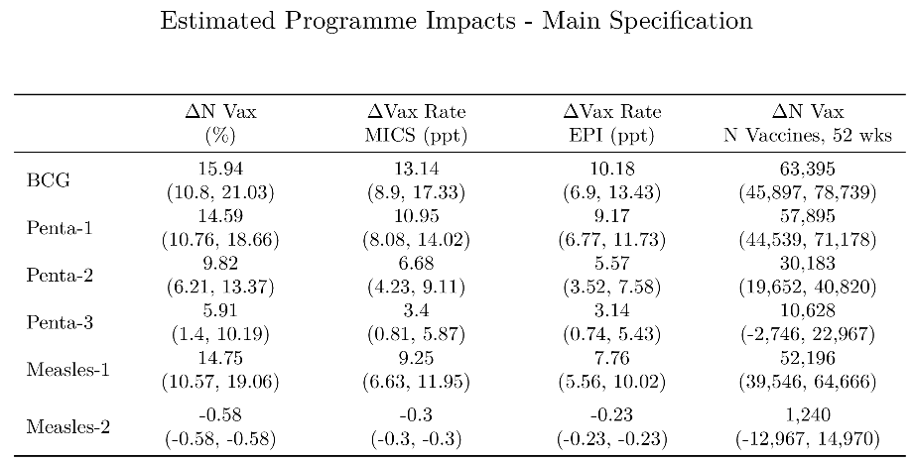
Impact of mCCTs for immunizations roll-in in Sindh, Pakistan: Preliminary Findings
Findings as of February 2024
Prepared by: Rachel Glennerster, Maryiam Haroon, and Edward Jee
With inputs from: Subhash Chandir, Danya Arif Siddiqi and Mubarak Taighoon Shah (IRD)
Note: Final decisions on interpretation of results were made by the Study PI Rachel Glennerster

Background
Several randomized control trials (RCTs) have found that relatively small transfers to caregivers, conditional on childhood immunization, can increase immunization rates (Banerjee et al. 2010, 2020; Gibson et al 2017). In Karachi, between 2017-2020, Chandir et al (2022) evaluated the impact of small mobile conditional cash transfers of different amounts and designs on childhood immunization rates. The program utilized a version of the Zindagi Mehfooz (Safe Life) electronic immunization registry (ZM-EIR) to trigger payments. The results showed that mobile phone top-up payments were more effective than electronic money and certain payments are more effective than lottery-based payments. While higher payments induced more immunizations than lower payments, the difference was relatively modest.
In response to these findings, the Government of Sindh, in collaboration with IRD and funding from GiveWell, agreed to introduce the program in seven of the high-risk districts of Sindh with the lowest immunization coverage of Pentavalent-3 and Measles-1 vaccines. Specifically, the seven districts fell into the lowest 20th percentile of Pentavalent-3 or Measles-1 coverage in the 2020 birth cohort, as measured by surviving annual infants in the Government of Sindh’s Electronic Immunization Registry (SEIR; previously ZM-EIR) in Sindh as of 31st August 2021. IRD implemented the scaleup of the program, called Choti Khushi (Little Joy) Immunization Incentive Support Program. The SEIR was used to determine eligibility for transfers. All vaccinations (outside some specific mass campaigns) in Sindh Province are registered in the SEIR, usually when the vaccinator swipes the QR code on a child’s immunization card with their phone. Entry into the registry triggers an automatic payment in the form of a mobile top-up to the phone number registered by the caregiver if the vaccination takes place in a clinic/outreach site in a district that has been rolled into the program.Researchers from the University of Chicago worked closely with IRD to evaluate the impact of the roll-in of the program. This report provides findings on the impact of the program using administrative data and preliminary findings from a household and phone survey designed to check for biases in the administrative data.
Roll-in of the mCCT program
Choti Khushi (Little Joy) was rolled-in to the seven targeted districts between January and August 2022. One district per month was rolled into the program in the order determined by a randomization conducted by University of Chicago researchers. Because COVID-19 social distancing meant that training of vaccinators could not be done at the district level but had to be done by town. This means that the district roll-in was spread across a month. In March (i.e. after Karachi East was already rolled in), it was agreed that the order of town roll-in would be randomized. Table A1 (in Annex) provides details of the randomized order for roll-in and the actual dates of introduction of the program in districts and towns.
Implementation followed the randomization very closely. The only minor deviations in the day of roll-in were observed during the roll-in in four out of five towns of district Central, two out of seven towns of district Kambar, and one out of four towns of district Hyderabad. In all cases, the roll-in order was maintained, and there was only a 1–3-day difference in launch dates from the originally specified plan (for reference, see Table A1 in the annex). The main reason for the deviations was the involvement of vaccinators and the respective District Health Officers in province-wide polio campaigns, crash immunization activities, and immunization week and, thus, their unavailability for program launch on the specified dates.

Implementation of the program varied from that in the mCCT program evaluated by Chandir et al. (2022) in the following ways:
- All caregivers in a town became eligible for payments under the program at the same time. This allowed for general advertising of the program in the community and government vaccination staff actively informed parents about the incentives. Initial communication activities included social media and cable TV advertisements, branded local vehicles, promotional SMS, and print advertisement materials including distributable cards with program information.
- Reminder texts to caregivers in rolled-in areas did not inform caregivers about the transfer or incentive amount in the reminder text. The concern was that caregivers who attended a clinic in a program area once might receive a text informing them of the top-up and then take their child to a nonprogram clinic for their next immunization and not receive a top-up and this would cause complaints and accusations of corruption. We would encourage IRD to send SMS reminders that do include the amount to be paid.
- The real value of the top-up payment was reduced by inflation. The pilot study set the incentive at 0.8 dollars for low versus 11 dollars for high (Chander et al., 2022). For the scale-up, the incentive amount rolled-in at the start of the program was 1.25 dollars (200 PKR). However, due to an increase in inflation, the value of the amount declined. The decline in the value can be attributed to the fall in the value of rupee and the rise in gas prices corresponding to a 27.6% increase in the consumer price index (CPI) from August 2021 to 2022. Furthermore, the Pakistan Bureau of Statistics estimates show that transport costs have risen by 63.1% since August of last year (2021). In response to this, IRD increased the incentive amount from 200 to 275 PKR (keeping constant dollar amount to 1.25 dollars) with a randomization order prescribed by the University of Chicago’s researchers.

Estimation Approach
In this section, we briefly outline our econometric approach, including the intuition for choosing this approach. For a fuller discussion, including the full specification, see Chandir et al. (2024) and the accompanying slides. Our estimation strategy leverages both random and quasi-random variation to increase the precision of the estimate and allow for the estimation of the long-run effect. We seek to address challenges for estimation, most of which lead to a reduction in statistical power and, thus, the precision of the estimated impact rather than bias. In other words, the challenges increase the risk that we find a null effect even though the true effect is different from zero. We introduce several techniques designed to increase precision. In one case, there is a tradeoff between precision and the potential for bias. In this case, we show results with and without the approach.
Outcomes
We use the log of the number of Pentavalent-1 and Measles-1 vaccines as our main outcome variables, although we also show results for other vaccines. Pentavalent-1 and Measles-1 were prespecified as our key outcomes of interest. We do not use the vaccine rate as our main specification as we do not have accurate and recent data for the number of children under the age of 2 (census and birth records are not accurate). In addition, children may come from other towns to be vaccinated making it unclear what the correct denominator should be for a specific clinic. However, we translate our findings into changes in vaccine rates by combining our findings with other surveys that estimate vaccination rates in Sindh.
Town level estimation: balanced panel Callaway Sant’Anna with Bayesian Smoothing
While we have random variation in timing of roll-in within the 7 districts selected for the program, we also know the algorithm by which the 7 districts were selected and exploit this to estimate the impact of the program even after all treatment districts have completed their roll-in (7 months). The 7 districts were chosen for inclusion if they fell in the bottom 20th percentile for Pentavalent-3 or Measles-1 based on coverage rates calculated at the start of September 2021 (more details of the selection process can be found in the annex). Both the specific vaccines and date of calculation were somewhat arbitrary: using different vaccines and dates would have led to a different 7 districts being selected for the program. Permuting over many different plausible selection rules we estimate the probability a district was included in the program: overall 5 additional districts had a more than 40% percent chance of being included in the program. In our estimation, towns from each district are weighted by the probability of being in the randomization. The 5 districts that could have been in the program but were not act as controls that allow us to estimate impact beyond 7 months.
As different districts were rolled in at different times, we use a balanced panel and the Callaway Sant’Anna difference-in-difference approach which separately estimates the impact of a change in policy for every time period following the introduction of the program (in our case we estimate weekly impacts). This approach compares the change (compared to a base period) in immunizations in towns that have been rolled in for a given number of weeks to those not yet rolled in. The estimate for any individual week is noisy as it uses only about 2 percent of the available data. We therefore use a Bayesian hierarchical estimation approach and assume there is an underlying (latent) impact which moves slowly between weeks but that there is week by week noise in estimating this latent impact. The assumption we make is that there is some relationship between week t and t+n and this relationship decays as n increases, i.e. treatment effects are more similar to those closer in time. We rely on the data to estimate this relationship. This assumption is not overly restrictive and gives us more precise estimates – primarily because the model estimates variation in estimated effects week-by-week is driven by noise rather than heterogeneous treatment effects.
While the above approach gives us a full mapping of the dynamics of the impact over time, a key policy question is the long-term impact of the program. Simply averaging across all the weekly impacts after the introduction of the program is one approach but will underestimate the long run impact if there is any lag between program introduction and full impact. We therefore estimate how long it takes for this dynamic impact to stabilize and annualize results using estimates after this cut-off date.
Individual level estimation
Not every young child is eligible to be vaccinated at a given time which means that in the time window after one town has been rolled in but before another has been rolled in, a caregiver may not have the opportunity to respond to the program. In a separate estimate, we therefore use individual level data, which includes a child’s vaccination due date, to estimate the impact of the program by comparing those children with the same due date for a particular vaccine in towns rolled into the program and those not yet rolled in. This approach also has the benefit of allowing us to better understand who responded to the program and how. We divide the sample into those who were already enrolled in the registry (i.e. had at least one vaccine) at program start with those not yet enrolled at program start.
Results
Under our preferred specification (a balanced Callaway Sant’Anna with smoothing) the long-term impact of the program is a 14.59 percent increase in the number of Penta-1 vaccines administered (95% CI: [10.76, 18.66]) and 14.75 percent increase in Measles-1 vaccines administered (95% CI: [10.57, 19.06]). Our preferred specification takes into account the ramp up of the impact over the first few weeks and estimates the long-term (i.e. post ramp up) effect, whilst adjusting for spillovers. Simply averaging the impact over all the estimated weekly impacts after the introduction of the program gives an estimate of 13.86 percent increase in the number of Penta-1 vaccines (CI: [10.66, 17.11]) and 13.47 percent increase in Measles-1 vaccines (CI: [10.14, 17.02]): This average has the advantage of being simpler but is likely to be biased downwards because it includes the initial weeks immediately following roll-in when the impact is yet to reach its full strength.
Table 1 shows the estimated effects across all vaccines using our preferred specification as well as the effects in terms of percentage points and total number of vaccines administered. Our preferred specification is in column 1.
Table 1: Estimated Program Impact - Main Specification
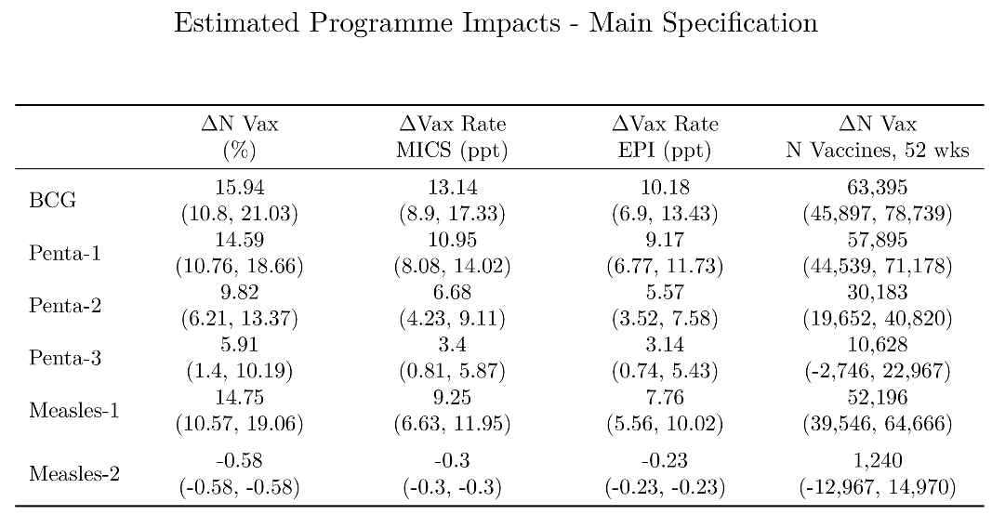

Figure 1 shows the dynamics with red dots showing estimates before the treatment is rolled in and blue after and lines around the dots showing confidence intervals. The black cross at the end shows our preferred specification and the yellow the average effect across all post treatment weeks.

Figure 1: Estimates for the log of Pentavalent-1 and Measles-1 in treatment vs control, balanced panel, 12 districts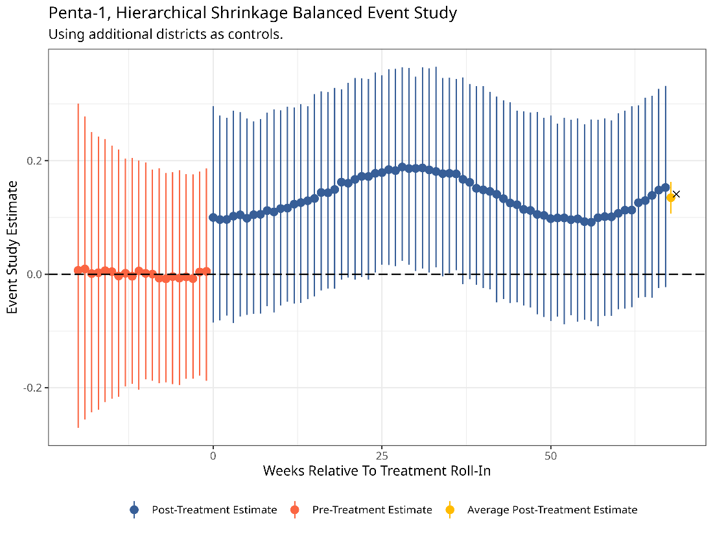
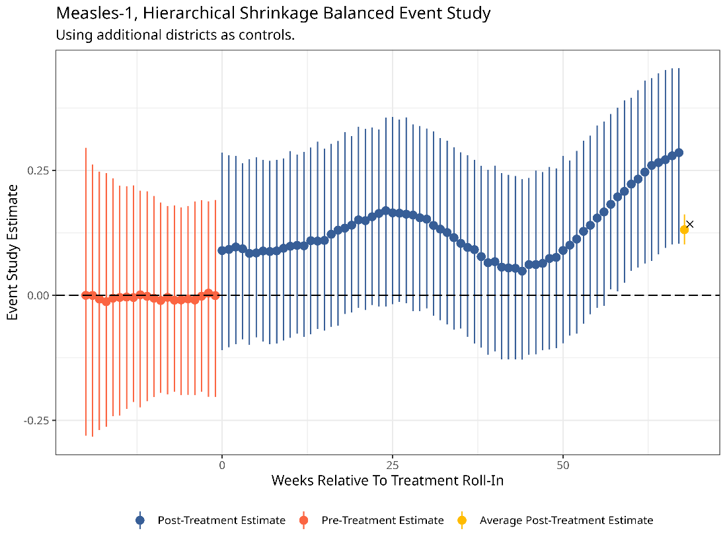
Note: Red dots show pre-treatment effects, and the blue dots are the estimates after the roll out of treatment. The black cross is the overall program effect. Bars around the estimates represent confidence intervals.
Measuring the impact 52-weeks after each town rolled into treatment, a 14.1% and 13.8% increase would be equivalent to 57,895 more Pentavalent-1 and 52,196 more Measles-1 vaccinations.
A rough estimate of the increase in the vaccination rate using MICS implies an increase of 10.41 percentage points (ppt) (CI: [8.01, 12.85]) and 8.45 ppt (CI: [6.36, 10.67]) in the Pentavalent-1 and Measles-1 vaccination rate respectively.
Sensitivity of the main specification
The table below shows our main specification, (which uses the additional 5 districts as controls after appropriately reweighting) alongside estimates just using the 7 experimental districts. The results demonstrate how important having the control districts is: the confidence intervals around the estimates without the control districts are enormous, ranging from 0 to 43% for BCG for example. Taking just the point estimates, excluding the control districts increases the estimated effect of the program on BCG while reducing it for other vaccines. However, the wide confidence intervals mean we can tell little from the purely experimental sample.

Table 2: Estimated Program Impact - Main specification with additional districts included and experimental districts only
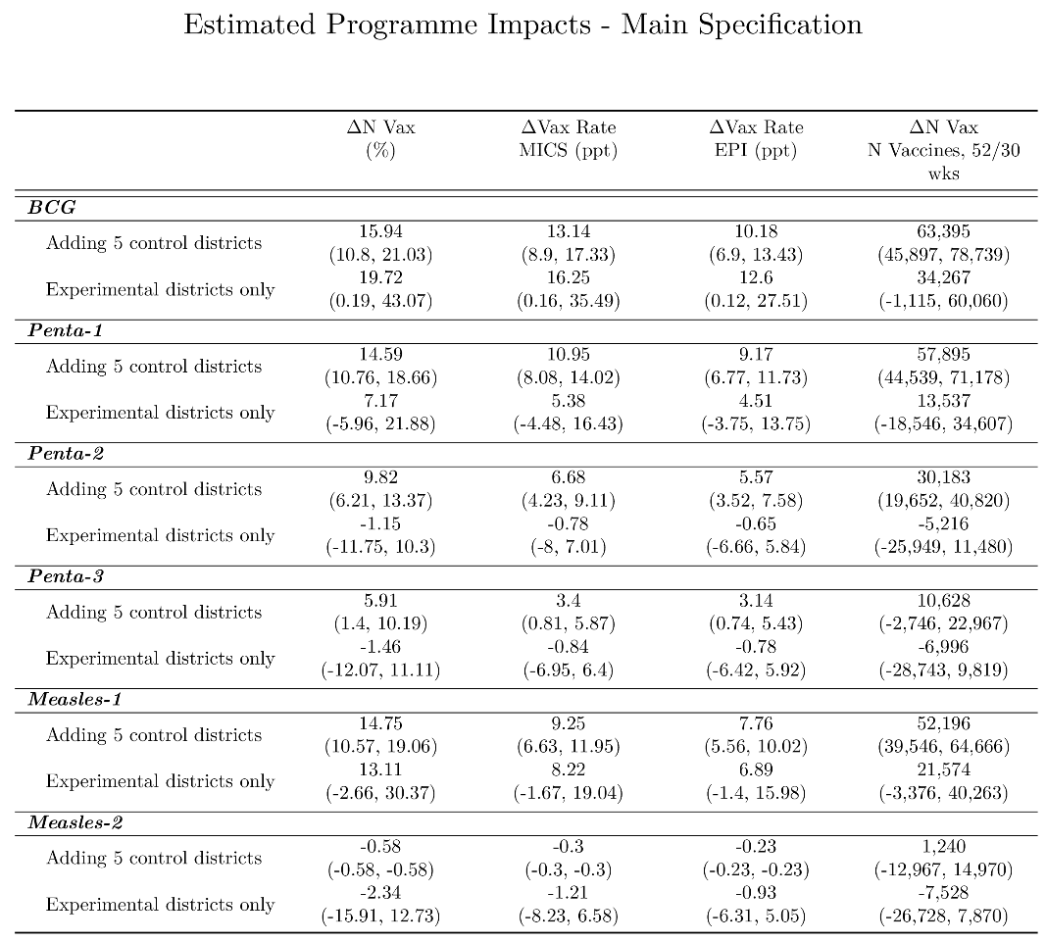
Individual level estimation
So far, we have not made use of the fact that we observe individual children’s vaccination status directly. Therefore, instead of estimating the number of vaccines administered per week per town, we create a panel dataset measuring the vaccination status of all children enrolled in SEIR. Comparing the change in the proportion of children vaccinated before treatment rolls-in to the change in proportion of children vaccinated after their town becomes treated lets us estimate the effect of the program, conditional on being in SEIR. As this analysis is conditional on being enrolled, these estimates cannot give the full impact of the program, but they can help us understand how different types of people responded to the incentive.
Since we also know when a child is due to be vaccinated, we exploit this information to only make comparisons between treatment and control children due in the same week. We split the estimates by enrolment status – those that enrolled before their town was treated, the “pro-vaxxers”, and those that only enrolled after their town was treated, a mix of “pro-vaxxers” and “marginal-vaxxers”. Among individuals that are enrolled before treatment begins, the program has negligible effect on Pentavalent-1 (the pro-vaxxers would have got Pentavalent-1 anyway) but increases the probability individuals persist and receive vaccines later in the schedule – we observe a 14.7 percentage point increase in the fraction of individuals that take Penta-3 in this group. Estimates for Measles-1 and Measles-2 are insignificantly different from zero mainly because we struggle to observe individuals that are due to take Measles that have enrolled close enough to the treatment date to be included in the sample.
Table 3: Individual Estimates - already enrolled in SEIR
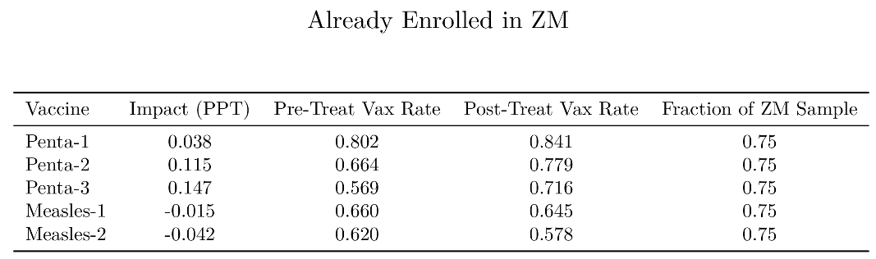
The group who enrolls after the program roll-in includes individuals who would have enrolled anyway as well as others who are induced to enter SEIR by the incentive. Since we do not know what fraction of individuals would have enrolled otherwise, we use the enrolment effect from the town level estimates and “pro-vaxxer” estimates from those already enrolled to backout the implied vaccination rate for the “marginal-vaxxers”. We find large effects on Penta-1, 74% of children induced into SEIR receive Penta-1, although these marginal children still have a lower vaccination rate than those already enrolled in SEIR, at 84%. However, these children are much less likely to persist to Penta-2 and Penta-3. We estimate a vaccination rate of only 29% for Penta-2 and we do not pick-up any increase for Penta-3. On the other hand, Measles-1 and Measles-2 both increase substantially, to 49% and 42% respectively (although still less than the “pro-vax” rate of 65% and 58% estimated above). This finding from the individual analysis is somewhat at odds with that from the town level analysis that finds no impact on Measles-2.
Table 4: Individual Estimates - induced into SEIR
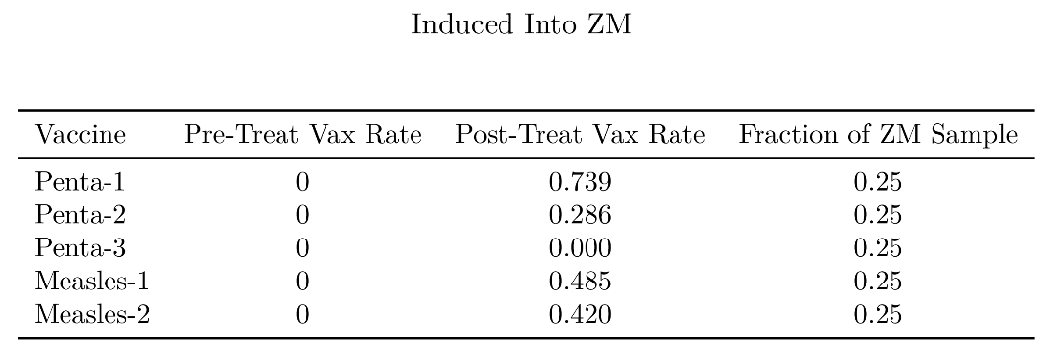
Crossovers
One concern with the validity of our estimates would be if caregivers realized that treatment towns were giving mobile incentives and other towns were not and switched where they took their child to be immunized as a result. This would push up vaccinations in treatment towns and down in control towns and give us a spurious positive impact of the program. We therefore test to see whether the introduction of the mCCT program was associated with an increase in the number of caregivers switching between towns to benefit from the program. This does not pick up people who switch district for the very first vaccine but as BCG is given in the birthing clinic or within a few days of birth we think it unlikely many will go out of district to give birth for the sake of 200-275 PKR or travel further with a child a few days old.
Figure 3 below shows that the rate of caregivers who bring their child to clinics in more than one town stays constant throughout the time for which we have data, at roughly 5 percent. Some switching of towns is to be expected particularly as women often go to their parents’ home at the time of the birth of their child (mostly for first child) and thus get the first immunization in their parent's town before returning home when the child is a bit older. In 2021 there are only control towns, and we observe a baseline switching rate of around 5 percent. The dashed line shows what we would expect with random switching: as more towns roll into treatment, if individuals swap randomly, the odds of switching into a treated town rise as shown by the rising slope of the dashed line in the “Control -> Treat” panel.
Our estimated impact of mCCT would only be biased if there were systematically more women switching into mCCT districts than those switching out of mCCT districts. Figure 3 shows that slightly more people switch from control to treatment districts. However, the magnitude is small and is not enough to substantially change our estimated impact of the mCCT program. Specifically, in the 15 months since the program started on average the rate of caregivers switching into treatment towns from control towns increased by 0.223 percentage points above what we would expect from the baseline random switching rate. Caregivers switching from treatment to control districts decreased by on average 0.355 percentage points above the baseline rate. We have already taken this into account in our headline estimation of impact.
Figure 2: Percentage of children who switch vaccination town by groups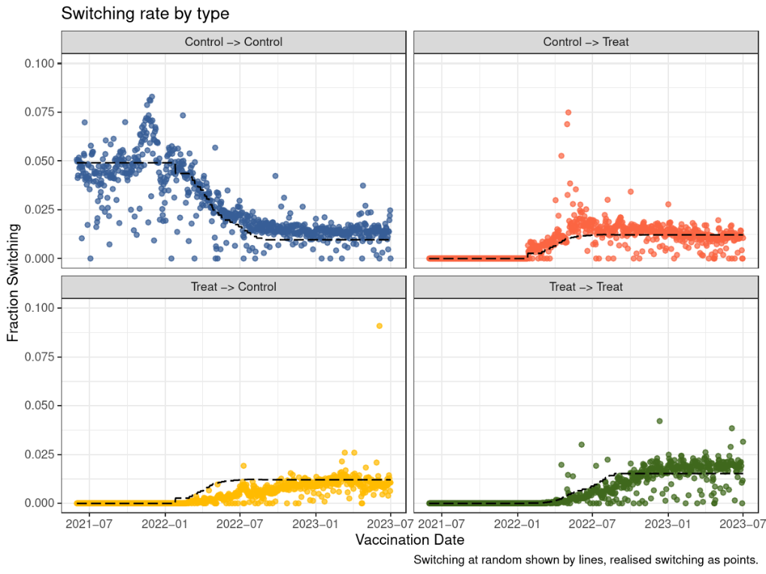
Note: The above four panels show switching from one group to another. Blue: switching from the control-to-control; Red: control to the treated group; Yellow: treated to control and Green: treated to treated group.
Conclusion of Part 1
We find that the mCCT program offering small incentive through a mobile top-up to caretakers (initially PKR 200/$1.25 for each incentivized vaccine and later PKR 275) increased Penta-1 immunizations by 14.59 percent (95% CI: [10.76, 18.66]) with 57,895 (CI: [44,539, 71,6178]) additional immunizations per year and Measles-1 immunizations by 14.75 percent (95% CI: [10.57, 19.06]) with 52,196 (CI: [39,546, 64,666]) additional immunizations per year in mCCT districts as a result of the program. We find that some people chose to get their children vaccinated in the program district, but the number of crossovers is small enough to make only a modest impact on the estimated impact (without adjusting for crossovers the results would be higher, 59,951 additional Penta-1 vaccinations and 54,036 Measles-1 vaccinations per year). Our results are driven by two mechanisms: the incentive brought more children into the system who otherwise would have received no vaccines, and it encouraged those already in the system to persist longer through the schedule and receive more vaccines.

Part 2 Checks on the Administrative Data (and evidence on spillovers to other activities)
Part 1 assessed the evidence of the impact of the mCCT program on childhood immunization using administrative data on immunization. In this section, we use a range of tools to examine the administrative data's reliability and whether there is evidence of incentive payments being systematically captured by people in the immunization system. Independent checks were conducted through two mechanisms: a phone survey conducted by the evaluation team to the caregiver’s phone numbers listed in the administrative data and a representative survey of households with children under 3 in two districts. The survey also allows us to examine whether the increased visits to clinics for immunization led to an increase in other care seeking behavior.
We start with a more detailed description of how the mCCT program works to identify potential weaknesses in the system that could lead to inaccuracies in the administrative data or be exploited by those seeking to extract money from the system.
- Background detail on the mCCT and SEIR system
Children are enrolled in the SEIR when they receive their first immunization as long as that vaccination is administered by any official vaccinator in the EPI program in the province of Sindh including public and private clinics as well as outreach visits. The only childhood vaccinations that are not captured are those administered during special campaigns by non-EPI staff—in particular when teachers and other government staff (who do not have SEIR-enabled phones) are recruited to give polio, measles, TCV vaccines in special immunization campaigns.
A QR code is added to the government-issued vaccination card at initial registration that provides a unique identity number to a child in the registry. Caregivers are asked to provide a phone number at initial registration (although they can be added or updated at later visits). Roughly 30.2% percent of caregivers provide phone numbers in non-mCCT districts. This rises to 83.5 percent in mCCT districts (where there is a financial advantage to providing a phone number). In both mCCT and non-mCCT districts, caregivers are sent text reminders when the child is due for the next immunization visit.
If a caregiver brings a vaccination card to a subsequent visit, the vaccinator scans the QR code which tells them which vaccines to administer. The vaccinator then vaccinates the child and enters into the system what vaccines were given. mCCT top-ups are tied to incentivized vaccines (BCG, Pentavalent-1, Pentavalent-2, Pentavalent-3, Measles-1 and Measles-2) and sent automatically to the registered phone number if the vaccinator records that vaccine as having been given. If the regular schedule is followed, then one top-up will be sent following each primary vaccine administration. However, there are reasons (in particular a vaccine being out of stock) when the schedule is not followed and a vaccine that is not tied to a top-up is given on its own and thus no top-up is given. For example, if a child is due for Pentavalent-1 (incentivized) and rotavirus (unincentivized) but Pentavalent-1 is out of stock during the visit and the child only gets the rotavirus vaccine, the child will receive a vaccine but not an incentive payment. This happens 8% of the time. If the caregiver does not have the vaccination card, the protocol is that the vaccinator will request the caregiver's mobile number provided during previous visits and use it to search for the child’s record. In case of unavailability of the mobile phone number, the vaccinator will use the child's name, father's name, National Identity Card number, gender, location (district, town and Union Council name), and date of birth to locate the child’s record and proceed with vaccine administration accordingly. If the vaccinator is busy, they may not look the child up at the time but register the vaccination when the clinic is quieter: if they fail to record enough information from the caregiver at the time of vaccination to link this to the correct child, it will show up as unlinked, for example, a Measles-1 dose without any corresponding Penta-1, 2, or 3. There are 0.001% of vaccines that are isolated vaccinations of this kind (excluding BCG).
- Data collection to cross check administrative data
We undertook two data collection exercises to cross-check the administrative data, the workings of the mCCT system, and possible spillovers. The first was a phone survey of a random sample of phone numbers recorded in the selected districts in the SEIR registry. The sample was chosen to ensure coverage from both mCCT and non-mCCT districts, to compare the types of people who added their phone number after mCCT was introduced. There was an additional sample in districts that match our household survey districts and, lastly, a fraction of the sample where there was evidence of “red flags” (discussed below). The second data collection exercise was an in-person survey of the representative sample of households with children under 3 in two mCCT districts. A major objective of the latter was to estimate an accurate immunization rate, as other sources of data on the number of children between 0 and 3 were potentially unreliable and outdated. It also provided an opportunity to check that households recognized the phone number on their immunization cards (though there could be a possibility that the number on the card may be different than that listed in the SEIR record or it is missing on the card but available in the SEIR system).
Details on phone survey
The phone survey was administered with a sample of caregivers enrolled in the Sindh Electronic Immunization Registry (SEIR). The sample was stratified based on mCCT and non-mCCT districts, gender, different time lags since the last vaccine and its timeliness and those who had registered before and after the roll-in of the program (detailed description on the phone survey and stratification is provided in the annex). We surveyed 2,131 caregivers between November 2022 to February 2024, with the main sample comprising 1,903 children selected from mCCT and 228 from non-mCCT districts. The table below shows the main results from the phone survey by district. The districts with a lower success rate and a high percentage of “child not recognized” are those districts where fewer people have their own phone. Where phone penetration is lower, people are more likely to give the phone number of a nonfamily member, increasing the chance that the phone owner will not recognize the name of the child. The number of calls in any one non-mCCT district is small, making it hard to draw conclusions on a district-by-district basis (we discuss differences in results for mCCT and non-mCCT districts in some detail below). We additionally targeted 25 centres from Karachi East and Kambar and interviewed 300 caregivers, where we find more unsuccessful calls (those reporting child not recognized, phone turned off, or no pick up). We also visited some of these hotspots in person during the household survey (these results are presented as an additional segment for Karachi East for now while we collect data for Kambar).

Table 5: Summary Statistics of the Phone Survey
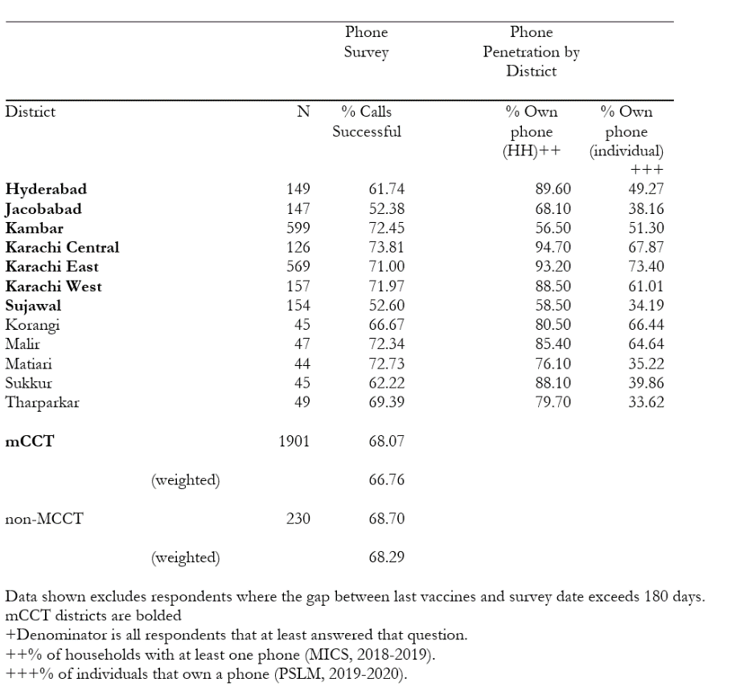

Details on household survey
We selected two mCCT districts for the household survey. The two districts, one urban (Karachi East) and one rural (Kambar) were selected for their representativeness of the seven districts in the mCCT program. We selected Kambar as a typical rural district: 95% of people speak the native (Sindhi) language. The immunization rates based on 12-23 months old fully immunized children through card record and recall are very low for Sujawal (51%) and higher for Jacobabad (89%), while Kambar has a 60% immunization rate, i.e. in the middle of the range. In Kambar, a substantial proportion of households have mobile phones (51% as compared to 38% and 34% for Jacobabad and Sujawal), with similar rates for the female population (49% for Kambar and Jacobabad and 48% for Sujawal) and the percentage of households with children under the age of 4 being similar to those of other rural districts (16% for Kambar and Sujawal and 17% for Jacobabad). It also offers decent security conditions for the survey and future programs. We selected Karachi East as it is completely urban compared to Hyderabad and Karachi West (83% and 93% urban) and offers considerable ethnic diversity (with 12% of the population speaking Sindhi language). In contrast to Karachi Central, where only 3% of its population speak Sindhi. Karachi East is representative in the proportion of females and children under the age of 4; however, it has higher mobile phone penetration than typical (Karachi East 73% and Karachi Central 68%) and slightly lower (54%) immunization rates (compared to 67% for Karachi Central).
We used the publicly available union council boundaries to divide each union council into equal-sized segments as the Pakistan Bureau of Statistics (PBS) did not provide updated representative segmentation for 2023. We randomly selected one segment per union council for the mapping, listing and full-scale household survey. While we used satellite google maps to attempt to make segments similar in population size within Union Council we do expect some variation in the number of households with children. The survey team mapped each selected segment and then conducted a household listing exercise. Each household was asked whether they have children under the age of three data on names and phone numbers collected to allow tracking of the household. We then chose a representative random sample to conduct a full-scale household survey among households with at least one child under the age of 3 in a given segment. We also administered listing and household surveys in additional segments identified as hotspots (i.e. areas with a high rate of concerns flagged through phone surveys), and the findings from those segments are presented separately. The household survey records the child's age, immunization and incentives received, and knowledge of the incentive program. Basic socioeconomic indicators were also collected, including income proxies, education, language, and ethnicity. Some additional modules on caregivers' preferences and cost shocks were also administered to launch the present bias program with selected households. The estimated total sample we plan to cover is 8700 households from the two districts. Currently, we have successfully interviewed 88% of households we have attempted to reach with refusals at 7% and 5% of households unreached because they migrated between listing and the household survey (we are following up migrated families so this number may fall).

Table 6: Summary Statistics of the Household Survey
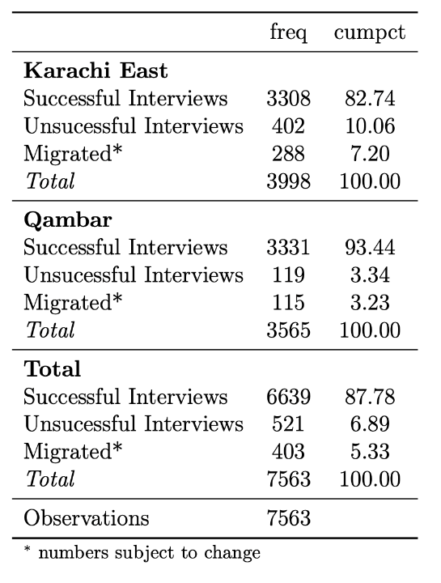

- Validation checks on areas where inaccuracies/fraud could occur
C.1 Vaccines not captured by SEIR. Vaccinators brought in temporarily to help with vaccine campaigns (like teachers conducting polio drives) do not have SEIR-enabled phones and the vaccines they administer are not recorded in the SEIR system. Many of the vaccinations given in these drives are to children already vaccinated. However, some children receive vaccinations they would not otherwise receive from temporary workers which means SEIR underestimates the total number of vaccines given in the province. For this gap in SEIR records to bias our estimate of the impact of mCCT, however, it would be necessary for there to be a systematic difference in the number of children receiving non-SEIR registered vaccines in mCCT and non-mCCT districts. This could happen through two mechanisms: campaigns could be more common in non-mCCT districts; and a given campaign reaches more unvaccinated children in non-mCCT districts (because vaccinations are lower there). As campaigns that bring in temporary workers are nearly always provincewide, we do not think the former is an issue. It is possible that some of the extra children vaccinated through clinics as a result of the mCCT program would have been picked up by campaigns but we dont have a good way to estimate the magnitude of this effect. As campaigns usually focus on polio or measles this would not impact our estimates for other vaccines.
C.2 Is there evidence of centralized diversion of top-up payments?
The most effective way to divert payments meant to go to caregivers would be a centralized system that diverted some proportion of the top-up payments to an alternative account. This would require collusion with one or more of the phone companies involved. An audit is the best way to check whether a macro-level kickback scheme of this type is in place. We can, however, ask caregivers both through the phone and household survey whether and how much they received as a top up payment. We find 69% report receiving the payment among those who should have received 200 PKR and 76% report receiving any payment among those who should have received 275 PKR in the phone survey. We consider these rates quite high given that some will not notice the payment, forget they received it, or say they did not receive it in the hope of getting another payment. The rate is lower in the household survey, though the rate of remembering payments rises for more recent payments (44% in Karachi East, 54% in Kambar Table 7c). One potential reason for the difference is that in the phone survey we interview the respondent with the phone that receives the payment whereas in the household survey we interview the caregiver at home, often not the holder of the phone.
For testing if there is systematic diversion of payments, a better test is how much people remember receiving. Note that some people will not receive the full amount as those in arrears with the phone company will have money automatically deducted from the transfer before they receive it. In the phone survey, among those whose last vaccine was before the change in payment amount, the modal amount was 200PKR (Table 7a). In the phone survey this was not the case after the change in amount to 275PKR. In the household survey however, which has a much larger sample, we see clustering at 200 before the change and at 275PKR after the change in payment. While there is clearly some confusion about exactly how large the payments are, we do not think these patterns are consistent with systematic skimming of payments because there are as many people reporting payments above the official amount than reporting below the official amount. The lower consistency of reported payments to actual payments after the change to 275PKR is understandable as many caregivers will have received both 200PKR and 275PKR for different visits.
We conclude there are no signs of a systematic central skimming of payments. We do think that the change in payments was not as comprehensively conveyed as the initial payment (one SMS was sent to caregivers who are in the system notifying them of the change in amount and for a post incentive notification was sent mentioning Choti-Khushi). IRD could also remind vaccinators to communicate the new incentive amount to caregivers. Another possibility is to include the incentive amount in the reminder SMS text as in the original RCT pilot.
Table 7a: Incentives Frequency (Phone Survey Results)
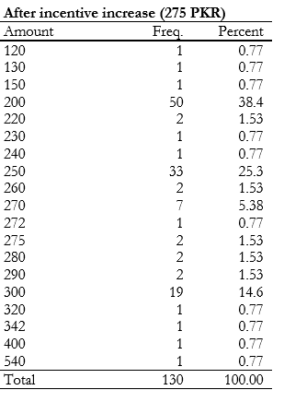
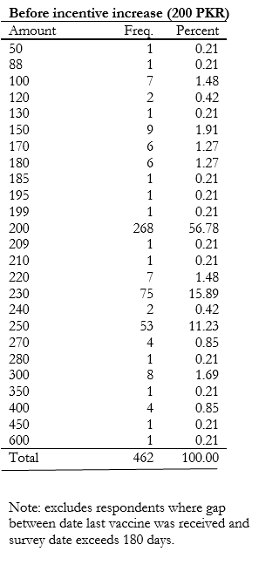

Table 7b: Incentives Frequency (Household Survey Results)
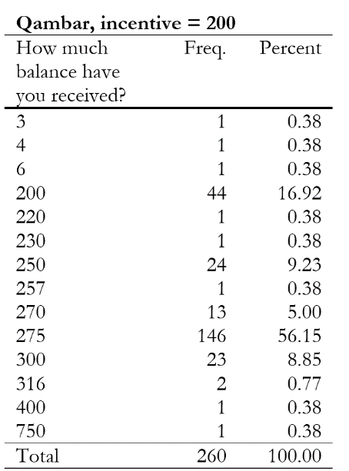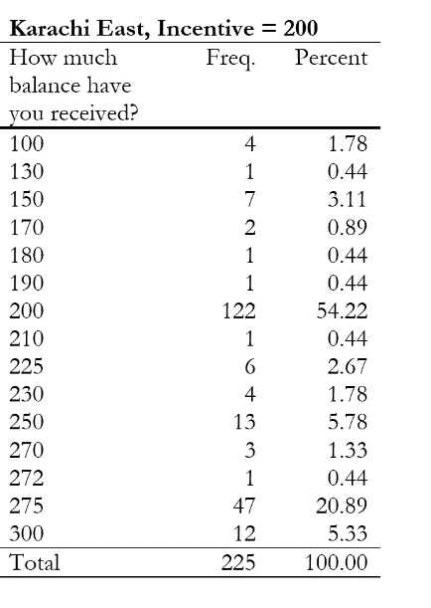

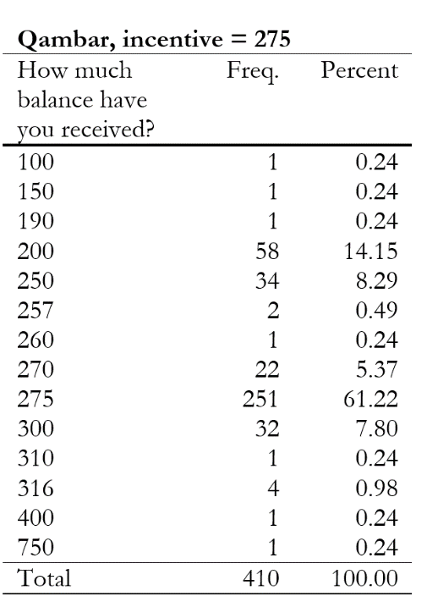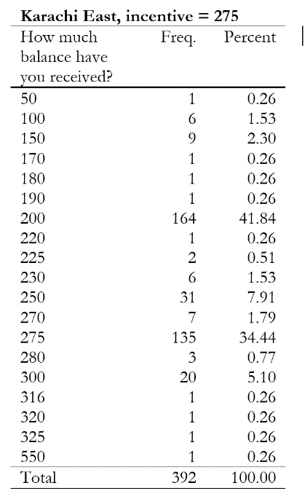

Table 7c: % Received Incentive (Household and Phone Survey)
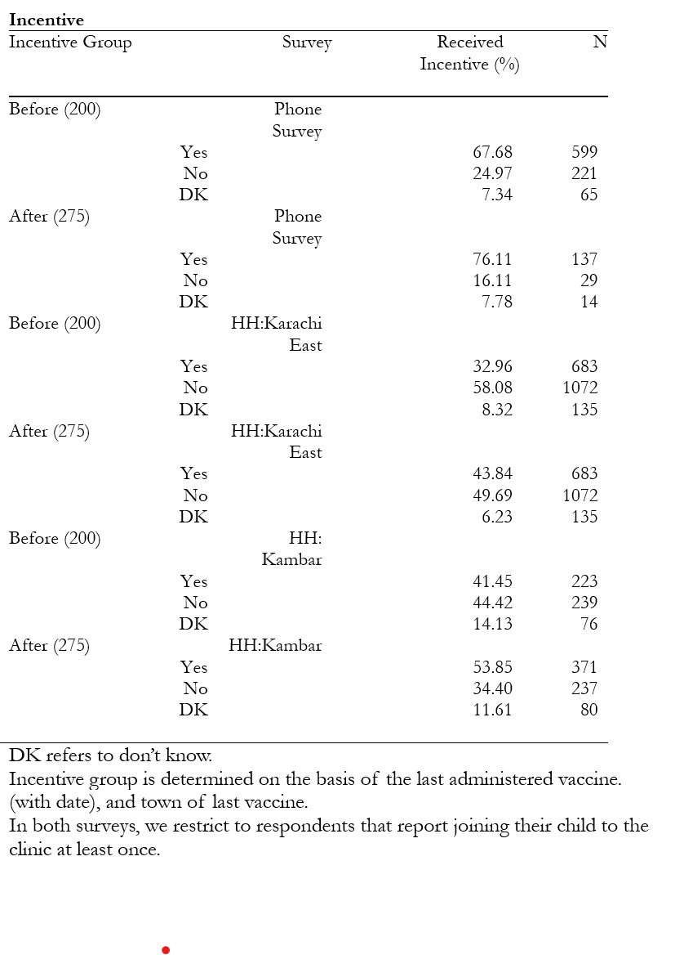
C.2 Do vaccinators make up fake children, or give their phone number to a real child?
A decentralized way for health staff to divert some of the top-up payments would be to make up nonexistent children, put their own or other family members’ phone numbers as caregivers, create false immunization cards and QR codes and register the fictitious children as having received immunizations with top-ups going to their phones. This would lead total vaccinations recorded in SEIR to be higher than actual vaccines and would lead our estimates in part 1 to be exaggerated. An alternative version would be to take real children and put their own (or relative’s) phone number on the card and get the credit whenever the real child got vaccinated: this would not distort total vaccination numbers or the impact of the program estimated in Part 1. Finally, vaccinators could add their own phone numbers to real children’s cards and then report they got more vaccines than they actually got. We undertake several checks to understand whether this decentralized diversion of top-ups might be occurring.
To collect anything other than a very minor sum (and create only a minor distortion in the data), the vaccinator would need to link several children to their phone number, buy many sim cards with a few children assigned to each sim, or include phone numbers for many of their family members. Anti-money laundering/anti-terrorist financing legislation in Pakistan makes it illegal to have more than 5 sim cards: a national registration (CNIC) card and biometrics verification for each sim card makes the 5-sim card rule hard to get around.
To investigate the possibility of decentralized diversion of top-up payments we undertake the following checks in the SEIR system, through the phone survey, and through the household survey:
In SEIR
We check whether the same phone number is listed for a suspiciously large number of children. IRD monitors cases where many children are registered with the same phone number and we check this frequency against reported sharing of phones in the household survey.
Result: In total, 89% of phone numbers are not repeated for different children in the SEIR database; 9.4% are repeated for 2 children; 1.3% are repeated for 3 children and 0.5% are repeated for 4 or more children. This is consistent with the number of people who report sharing phones across multiple households in our household survey: 90% in Karachi East and 70% in Kambar report not sharing a phone across households, while 2% of households in Karachi East and 11% of households in Kambar share phones across 3 or more households.
Table 8: Shared numbers across children in the SEIR database
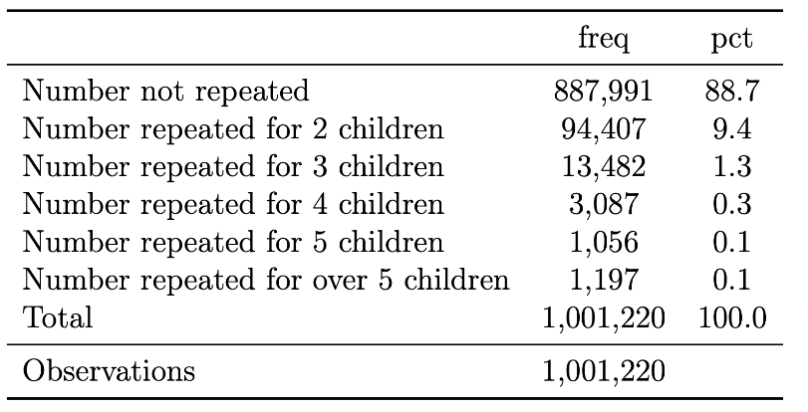
In the Phone survey
We check whether we can reach phones listed in the registry. If a vaccinator bought many sim cards to receive top-ups, they would be unlikely to pick up the phone when called as the sim would not be in frequent use. There are many legitimate reasons for people not to pick up calls from unknown numbers, including not having charge on a phone, being out of range of signal, being unwilling to take calls from unfamiliar numbers, and a number no longer working. We therefore compare pick up rates between mCCT and non-mCCT districts and between our survey and other surveys to test for systematic differences.
Result: We find no evidence vaccinators are buying extra sims to accumulate credit as phones are mainly reachable. Specifically, the percentage of people who pick up our call is high compared to other surveys (Table 9). The rate of phones turned off is lower than most surveys and is not systematically worse in mCCT than nonmCCT districts (it is lower in one time range and higher in another). The rate of unreachable phones increases with the length of time since vaccination (suggesting changing phone numbers is an issue). Our overall success rate (ie completed surveys) is 88% in mCCT districts when the vaccination was less than 30 days ago and 76% for those vaccinated 30-60 days ago. This compares favorably to other surveys we have conducted in Pakistan (64% in a recent survey).
We check if those responding to the phone survey know the child registered under their phone number. Legitimate reasons for the respondent not knowing the child include caregivers who do not have a phone giving the phone number of a prominent member of the community, people changing phone numbers, and a reluctance to respond to our phone survey and thus claiming they do not know the child. If failure to know the child is due to changing phone numbers, we would expect the rate of “child not recognized” to increase the longer the time since the last immunization and we would not expect this to be different between mCCT and nonmCCT districts. If it is due to near relations not having phone numbers, it will be more common in areas or populations with low phone penetration and may be different between mCCT and nonmCCT districts (if people without their own phones are more likely to give a phone number in mCCT districts). If it is due to a reluctance to talk to us it will be more common in refugee populations. (Afghan refugees have been asked to leave Pakistan making them particularly reluctant to talk).
Result: We find the rate of “child not recognized” rises sharply as the time since the last vaccination increases in both mCCT and nonmCCT districts (the exception is nonmCCT districts with time since vaccination of 60-180 days which appears to be an outlier). This suggests changes in phone number are a major driver. When the time periods are less than 60 days (ie the most reliable time periods), the difference between “child not recognized” is roughly the same between mCCT and nonmCCT districts. The results for periods over 60 days show a higher rate for child not recognized in mCCT districts but this is mainly driven by the result for the period 60-180 days for nonmCCT districts which looks like an anomaly.
While we believe the data from the more recent vaccination visits are likely to be more reliable, and there are no differences between mCCT and nonmCCT districts there, we nevertheless dig deeper into the issue of child not recognized in the household survey and hotspot results (where we investigate specific clinics with high rates of child not recognized).

Table 9: Phone survey results across mCCT and non mCCT over time
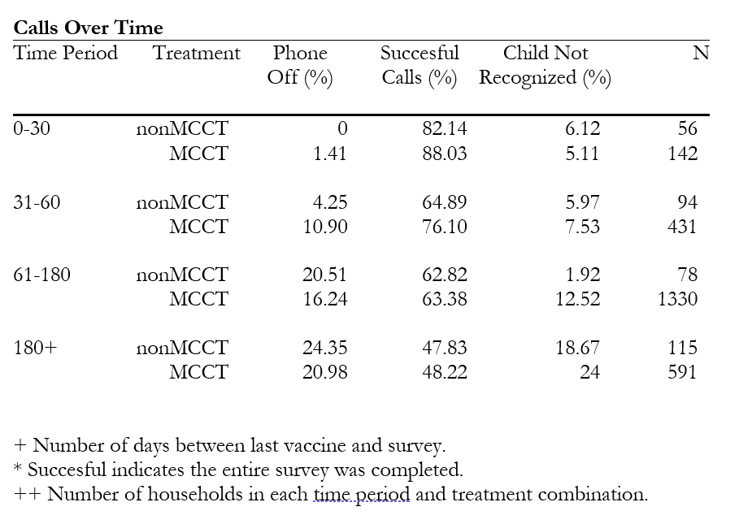

In the Household survey:
Are the correct phone numbers on vaccination cards? In the phone survey we checked that phone numbers in SEIR are for people who got their child vaccinated. In the household survey we do the reverse: we check whether people who got their child vaccinated recognize the phone number on their vaccine card, and whether the phone numbers they report are in SEIR. We also check whether the rate of “child not recognized” cases in the phone survey are reasonable given the rate at which caregivers give phone numbers that are not theirs.
Specifically, the protocol is the following: We ask to see immunization cards and ask about the phone number on the card. We also ask what number they used to register their child in SEIR, we verify the ownership of that phone and ask if they got a mobile balance. We ask for phone numbers in their family, and what number they would give if asked to enroll in a new program that gives a payment or a government service. We seek to collect multiple phone numbers per household to see how common it is to share and switch phone numbers (in total we ask for phone numbers 5 times in the survey). We link households to their entry in the SEIR database and check if phone numbers match.
Results: There is a high match between the phone number that caregivers report giving to SEIR and the phone number on the vaccination card. In Karachi East, 91% of phone numbers match, while in Kambar 94% match. We regard this as a high match rate given that within one survey many caregivers give different phone numbers for different purposes (see details below) and thus could easily misremember which number they gave to the vaccinator or change that number over time.
In 384 cases (7.5%), caregivers reported not giving a phone number to vaccinators yet there was a vaccine number on the card. This might suggest that the vaccinator had registered them under someone else's phone number to get their credit. However, after digging deeper, this does not appear to be the case: in 280 of these cases the phone number on the card matched one the respondent had given to the enumerator during the survey (suggesting they had forgotten giving a number to the vaccinator or they had not been the one giving the number). This means we are left with only 108 cases with potential concerns about someone else's phone number on their card out of 2,875 households with cards.

Table 10: Respondent reported not giving a phone number/being asked for one, but the number on the vaccination card matches at least one of the numbers the respondent provides
Karachi East
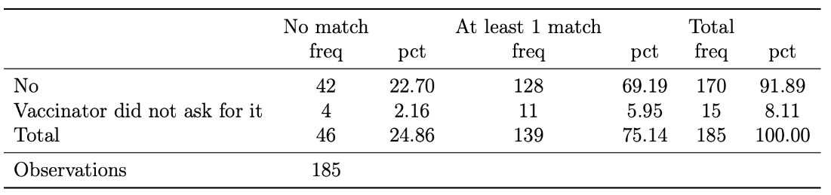
Kambar
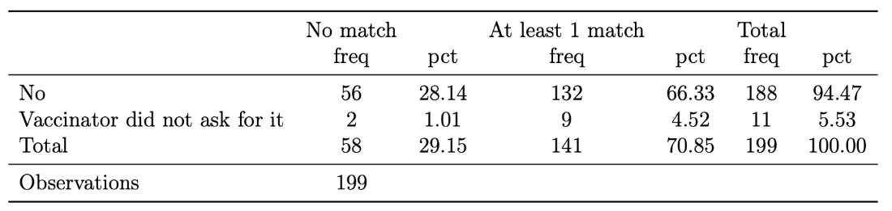
Note: Conditional on reporting not providing a phone number or not being asked for one, we check whether there is a phone number on the vaccination card and see if it matches any number provided by the respondent
We test the extent to which households give different phone numbers for different situations which might explain the lack of matches between phone numbers reported as being given to SEIR and phone numbers in SEIR. We request a phone number for enrollment in a new initiative (the present bias study currently being rolled in with the household survey). These numbers are intended for sending incentives to qualified caregivers who are rolled in the study. We assess the prevalence of submitting a new phone number upon enrollment in this program to understand the frequency at which caregivers change their phone numbers. This also involves comparing the phone numbers provided for enrollment in the new program to those listed on the vaccination card.
Result: We find a high proportion of people give a different number for a new program than they gave to SEIR. Remember that for 91-94% of people, the number on the vaccine card is the one they report giving to the vaccinator. Yet despite this, 41% in Karachi East and 30% in Kambar give a different number when asked to enroll in a new program. This may partly be because households have multiple phones, but it also means that the high rates of “child not recognized” for time periods over 60 days may well be a result of people changing phone numbers.

Table 11: Phone number provided on vaccination card and enrolment into a new program
Karachi East Kambar
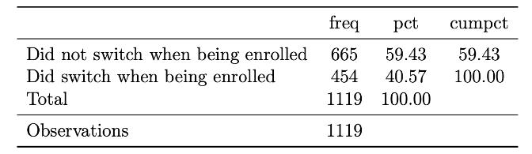
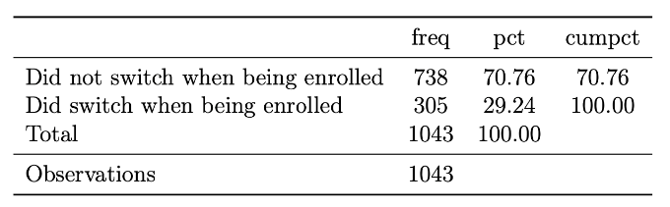
Note: Did not switch when being enrolled means that the caregiver provided the same phone number for enrolment in the present bias program as that listed on the vaccination card.
We check how common it is to share phone numbers. We use the household survey data to match across households to check how common it is to share phone numbers between households. (As households may include multiple couples with children—eg brothers and their wives—we repeat the exercise for couples within the same household in the appendix). The households could be residing in the same or different dwelling (a household is defined as those who eat together from the same pot). Caregivers might provide family members, neighbors, or friends' phone numbers to vaccinators, which could possibly lead to a child not being recognized when we call them during the phone survey. We collected five phone numbers for each household during the survey. We compared all five phone numbers collected in the household survey across households and couples to determine the frequency with which households share phone numbers (results for couples in appendix).
Table 12: Phone numbers shared across households in the household survey
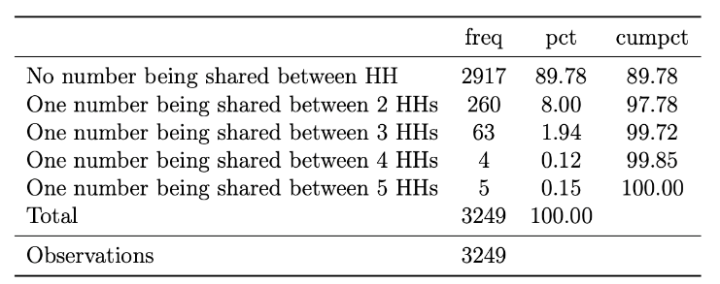
Karachi East Kambar
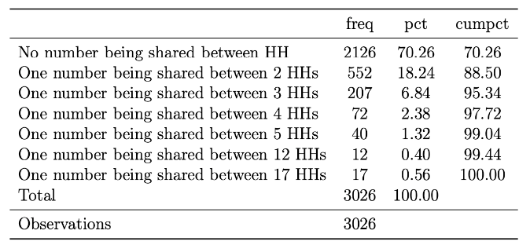 Note: No number being shared between HH means that each households have a unique number. One number being shared between 2 HHs means that there is at least one common number between 2 households. The left panel is for Karachi East and the right panel is for Kambar.
Results: Most households do not share phones across multiple households (90% in Karachi East and 70% in Kambar). However, there is a reasonable minority that do share a phone across multiple households especially in Kambar. When a phone is shared between at least three households, we conclude it is reasonable that at least sometimes the phone owner will not recognize the child's name (given there are many children per household). Households share their phone across 3 or more households in 2% of households in Karachi East and 11% of households in Kambar compared to around 6% of calls where a child is not recognized. The rates of sharing at least one phone between two or more households are much higher (10% in Karachi East and 30% in Kambar).
Clinic survey
We sent in-person teams to visit clinics in the districts where we planned to do the household survey. Two clinics were selected from each district. One of these clinics was identified as a hotspot through the phone survey. These hotspot clinics had the greatest number of phones turned off, children not recognized, and no pickup calls in the phone survey (more detail on hotspot results below). The clinics were visited on random days without informing vaccinators. The evaluation team visited the clinics with the monitoring team to verify whether the incentive was sent or not and the number on which the incentive was on the spot. All caregivers who visited the clinic on the day of our visit were interviewed, and we were successfully able to survey 13 respondents from four clinics. We expect people to respond more accurately during clinic visits and provide reliable answers than in phone surveys because we see them face to face. The caregivers were asked about the child's last vaccination visit and whether they received the incentive or not. During the visit, we were also able to verify if the caregiver recognized the phone number listed on the card and in the SEIR system. One downside of clinic visits is that it is only possible to interview caregivers who visit centers for vaccines (ie it tells us nothing about those who do not vaccinate their children).
Results: Most caregivers were visiting for later vaccines in the schedule and knew about the incentive. One was visiting for the first time. Most caregivers verified receiving incentives: 2 out of 13 did not remember receiving incentives. All caregivers could confirm the phone number stated on the card and that reported in the SEIR database. Those who had earlier denied receiving incentives were also able to verify the phone number in the SEIR system. This suggests people do not notice or do not remember receiving incentives or are not aware it was received (e.g. the incentive goes to the male of the household while we interview the mother). We found some discrepancies in the vaccine information stated on the card and the SEIR. We found entries for the vaccine was missing on the card, but present in SEIR (presumably because the card was not brought for all visits). We also found one case where there were vaccines on the card but not in the system. Based on other evidence we think this is likely to reflect some vaccines at birth not being linked to later records of the same child. Note that this does not alter the SEIR estimate of the total number of vaccines in a district. This finding from the clinic visit was similar to our findings when we matched household data with SEIR data. In sum, our clinic visits (while small in number) enabled us to understand why we might see discrepancies in other data (for example people saying they did not receive an incentive). Despite targeting clinics with high discrepancy rates, we found no evidence of fraud.
C.4 Checks for whether SEIR overestimates vaccinations
If vaccinators are making up extra vaccinations for real children, then we would consistently find more vaccinations in SEIR than in household surveys when we match records. We used the household survey data and matched it with SEIR data to link the records. We started by matching on QR codes when households had their vaccination card and then moved to match on phone numbers when households gave us phone numbers. In Karachi East, we were able to collect QR codes for 1,413 children out of 2,399—59% of the total sample of children. In Kambar, we were able to collect QR codes for 1,194 children out of 2,336—49% of the total sample of children. There are several reasons why caregivers might be unable to provide their child’s vaccination card: they could be misplaced, discarded, or the caregivers might be unwilling or unable to fetch the card. When we have QR codes, we can successfully match a substantial proportion: we fail to match only 33 children from Karachi East and 50 from Kambar. After matching on QR codes we matched based on all reported phone numbers for children that did not have a QR code. Through this process, we are able to match an additional 525 children in Karachi East and 444 from Kambar. After linking the two datasets, we check to see if vaccination records are the same in the household survey as they are in the SEIR database. Reasons of lack of a perfect match include households forgetting about some vaccines (when match is on phone number) and vaccinators not putting vaccines into the system because the internet was down when the child was vaccinated, or the clinic was too busy and they forget afterwards.
Table 13: Linking household survey data with SEIR data using QR codes
Karachi East
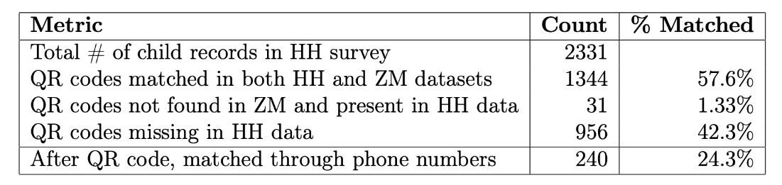
Kambar
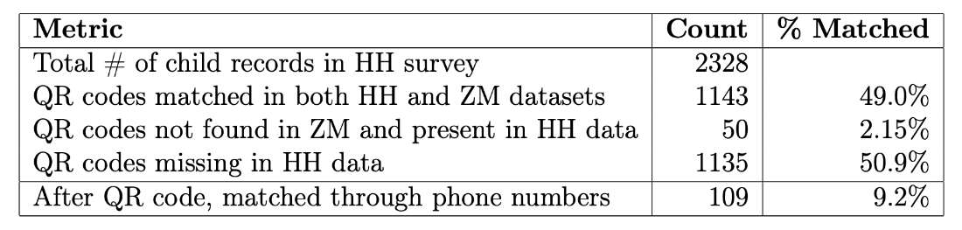
Note: The upper panel is for Karachi East and the lower panel is for Kambar.
Table 14: Linking household survey data with SEIR data using phone numbers
Karachi East
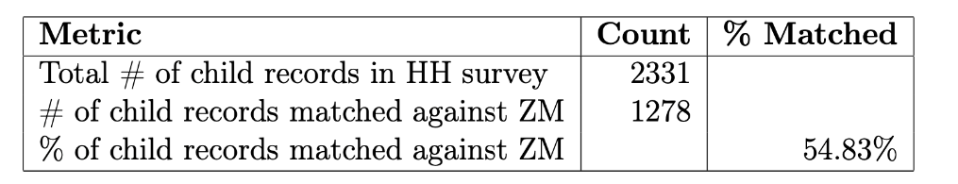
Kambar
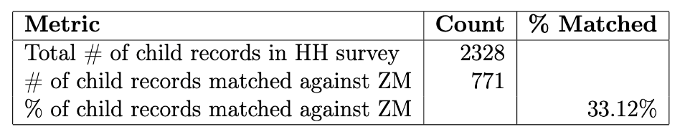
Note: The upper panel is for Karachi East and the lower panel is for Kambar.
Using the subset of observations from the household survey matched through QR codes and (separately) those matched on phone numbers, we calculate the consistency between the household survey (relying on vaccination cards), and the SEIR records, at the individual vaccination level.
Results: We find high rates of matching between the reported vaccinations in the household survey and the SEIR: for Karachi East using matches on phone numbers, we get an average match rate of 91% while in Kambar its 80%. Whether we use QR codes of phones does not alter results much. The mismatch goes both ways. Take Penta-3 using matches on phone numbers: in 91% of cases the household/card and SEIR report the same vaccine status. Of the 9% of mismatches about half (ie 4.5% of total cases) show vaccination for Penta-3 on the card but not in SEIR while in 4.5% of all cases SEIR reports the child has Penta-3 but the card does not. For most vaccines the recorded vaccines are higher in SEIR than on cards, although the absolute numbers are small. For BCG and Polio-at birth, however, cards show higher vaccination than SEIR. After investigation we think this reflects a quirk in how vaccinators record vaccines that were given before a child comes to their center (common for vaccines given at birth), the caregiver has lost the card, and the vaccinator cannot find them in the system. In all cases these previously given vaccines are put on a new card and usually entered into the SEIR as “retro” ie given to the child previously (in which case we find a match). For BCG and the Polio at birth, they are more likely to be entered as “missing” (and will count as a mismatch). This quirk in the system does not impact our estimates of the total number of vaccinations driven by mCCT from Part 1 as neither show up as vaccinations undertaken by a clinic in a given week (they would show up when they are first given by the original clinic).

Table 15a: Matching individual vaccines between household survey and SEIR using QR codes
Karachi East
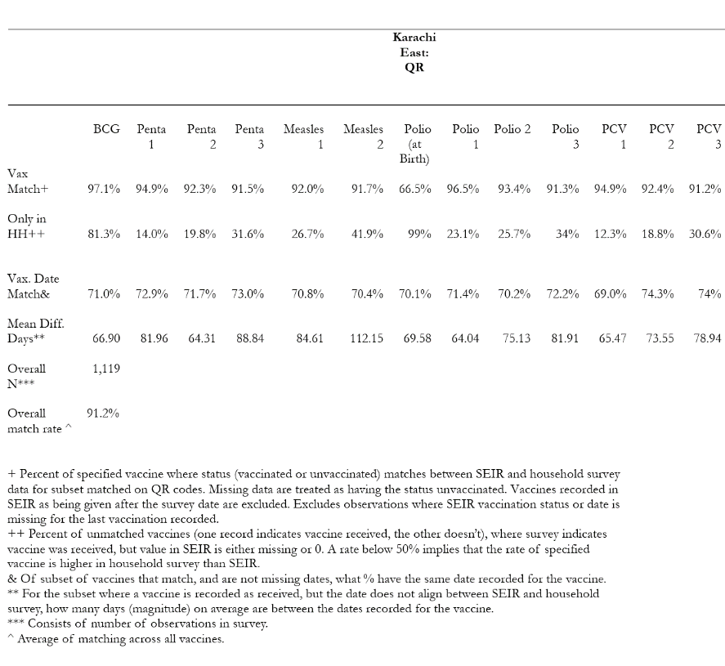
Kambar
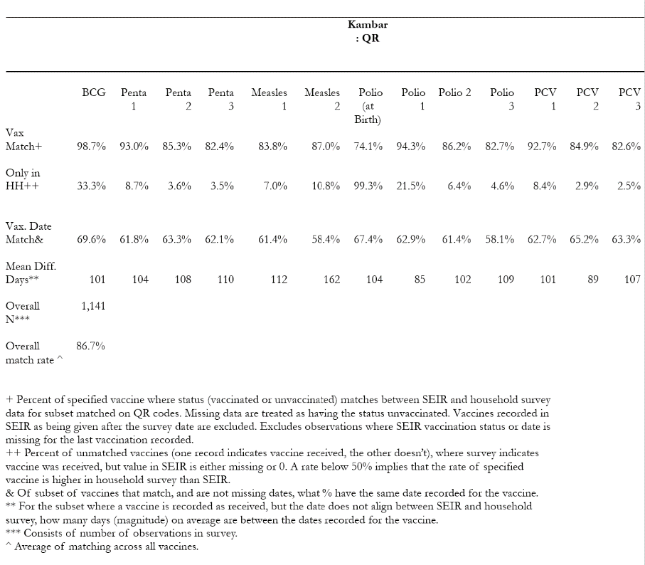
Table 15b: Matching individual vaccines between household survey and SEIR using phone numbers
Karachi East
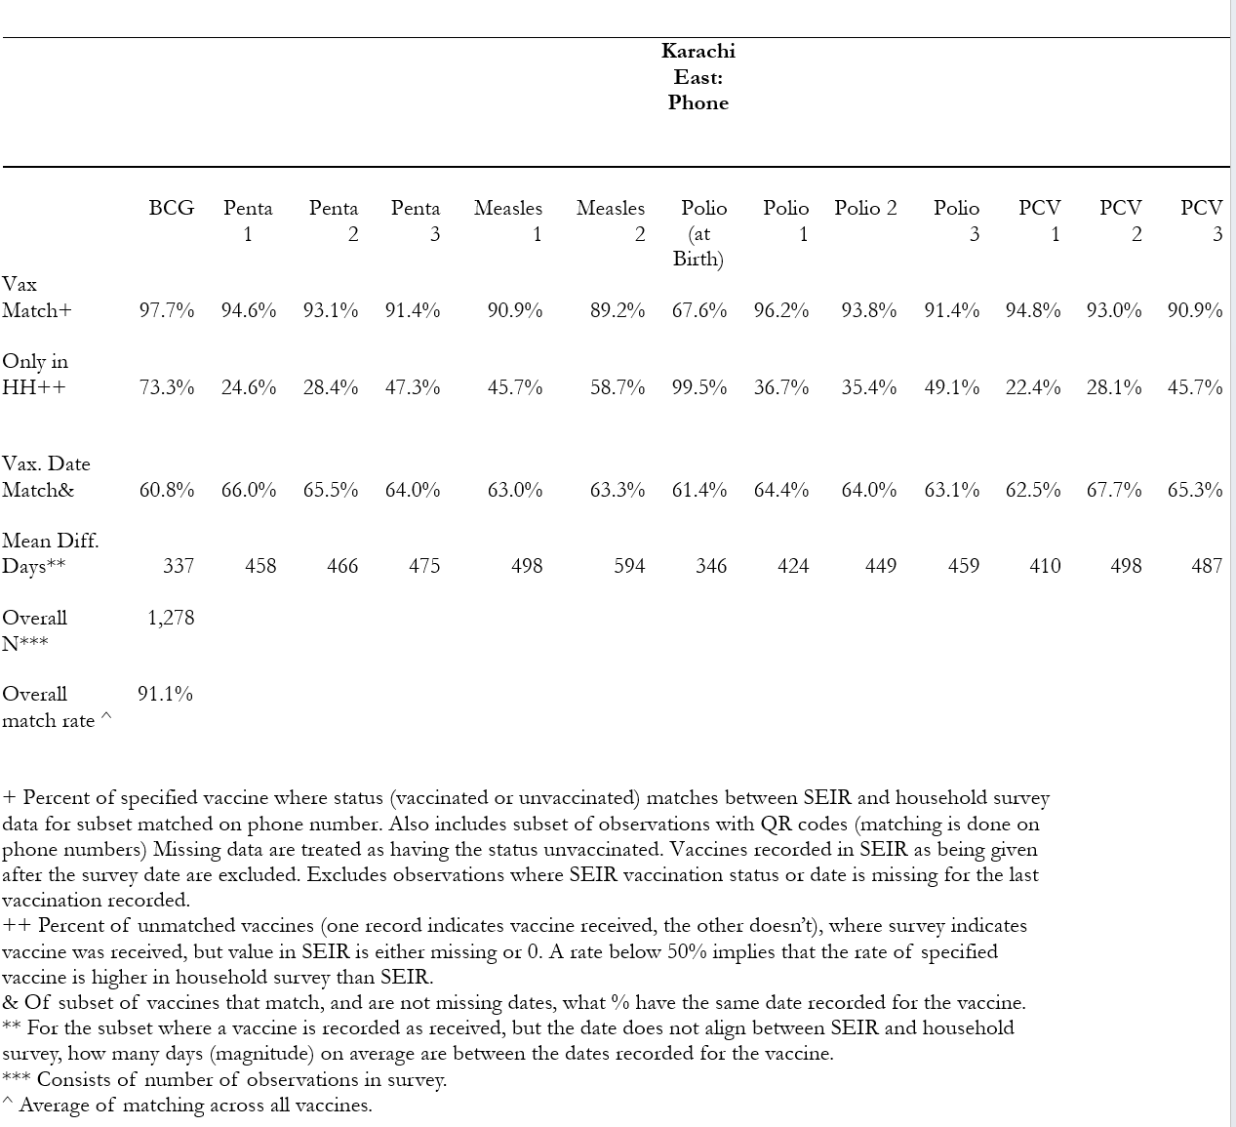
Kambar
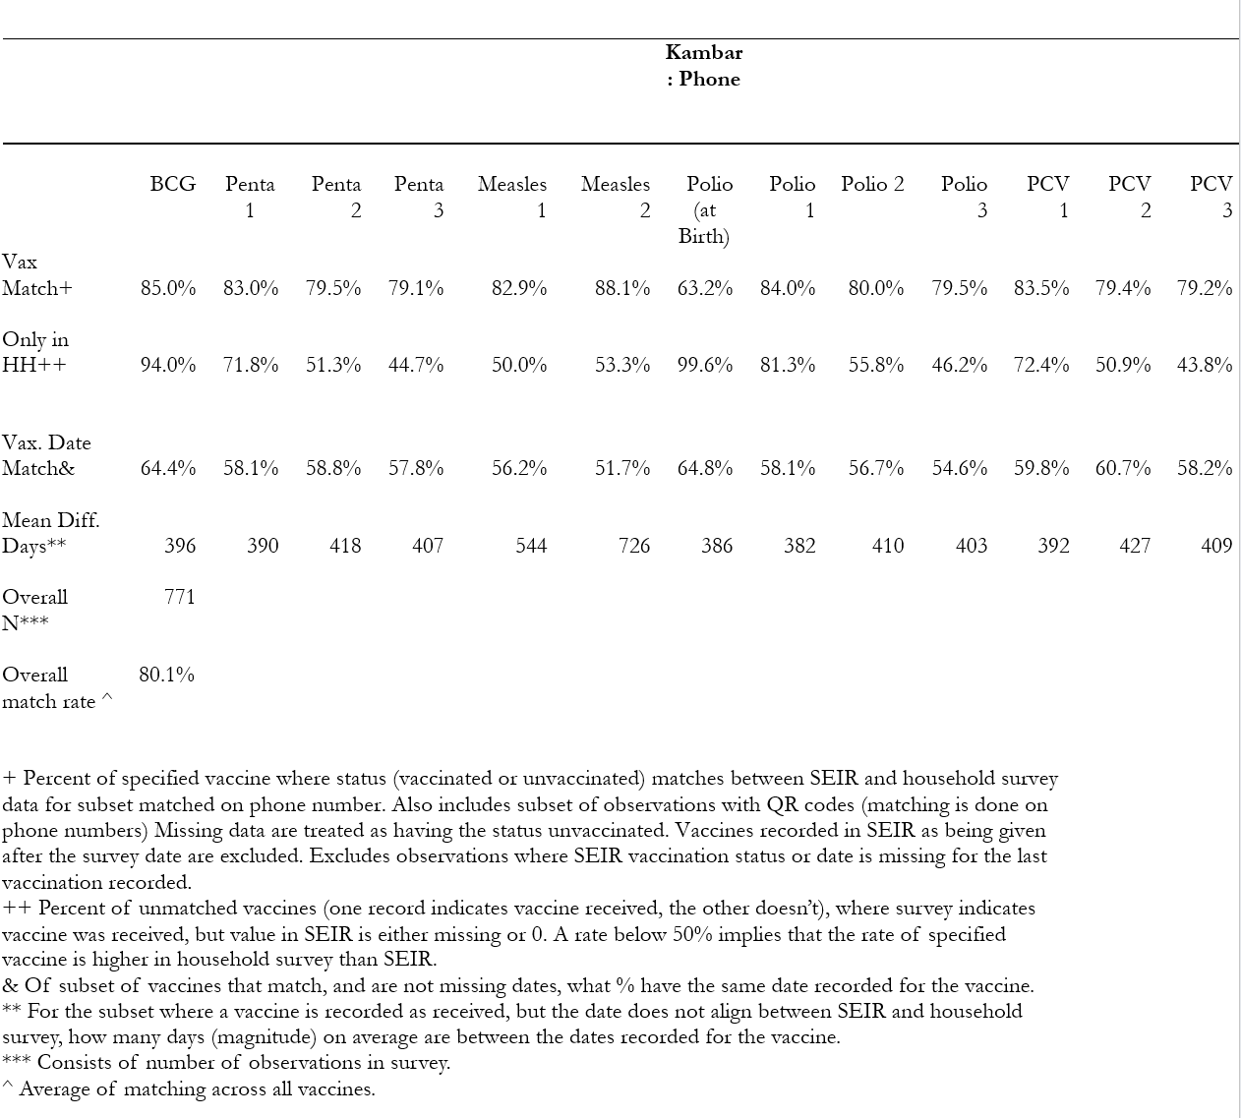
C.5 Does increased vaccination use increased use of other health services?
Caregivers who are induced by the mCCT program to go into clinics to get their child vaccinated may end up using other services. This is a potential additional benefit of the incentive. We cannot know if the caregiver would have gone to the clinic to receive the other service even if they had not vaccinated their child, but we can track how many caregivers get services when they get their child immunized. Over 74% of caregivers from the phone survey reported that there are other services offered in the clinic where they last got their child vaccinated (weighted to adjust for the oversampling of caregivers in Karachi East and Kambar). Overall, 16% of people in the phone survey said they used other services but this varies a lot between rural and urban areas.
In the household survey, almost 90% of caregivers reported at least one of the listed health services available at a vaccination center in Kambar, with about 85% reporting that they had used at least one of these services. The utilization rates are lower in Karachi East with 66% reporting availability of additional services and 43% have used at least one service. Of those that indicate they prefer to use clinic’s with other services, in an open response, 10% indicate it is due to the availability of free medicine, and 45% indicate it is due to the good quality of services available.
Only in the phone survey do we ask which services were used. The most frequent is to get medicines (which is also the preferred reason for visit to the clinic as reported in the household survey) from the dispensary followed by maternal checkup and then asking advice on child sickness. For more details on what services are available at clinics see the appendix.
Table 16a: Use of Health Services During Last Vaccine Visit (Phone Survey Results)
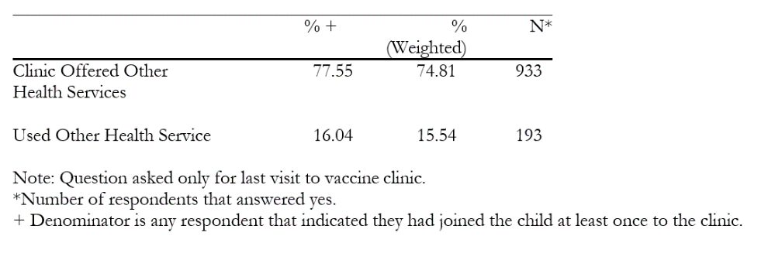
Table 16b: Health Services Used During Last Vaccine Visit (Phone Survey Results)
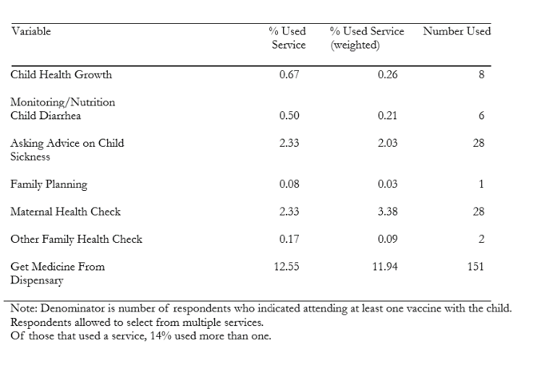
Table 16c: Use of Health Services During Last Vaccine Visit (Household Survey Results)
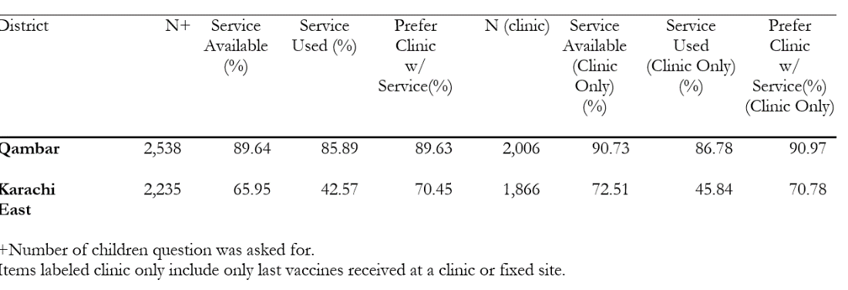

C. 6 Investigation of hotspots
If fraud were occurring at a decentralized level, we would expect to see problem areas with higher rates of discrepancies. Some variation in discrepancies between clinics would be expected by random chance and due to different geographical conditions. To distinguish between concentrated fraud or random variation we looked in the data from the phone survey, identified “hot spots” with higher than normal rates of phone turn off or child not recognized, and did a concentrated deep dive in those areas with additional phone surveys as well as implementing the household survey. Enumerators have not yet gone to hotspot areas for the household survey in Kambar but they have completed them in Karachi East and we did additional phone calls in both districts. With the data we have, we do not find very different results from these hotspot areas than in the population overall suggesting that the higher discrepancies in the initial phone survey were more likely to be random chance. In Karachi East, after additional phone surveys were administered the rate of successful calls in hotspot areas ended up being similar to the district as a whole. In Kambar, the success rate in hotspot areas remained low (54%) compared to that in the district as a whole (72%), Table 16. We find the match rate for which vaccines were completed in the hotspots in Karachi East are very similar to that for Karachi East as a whole. Similarly, the direction of the mismatch is similar (ie the proportion of the mismatch that comes from vaccines in the SEIR missing on the card and vice versa). On incentive amounts we see, as in the larger sample, that as many people report higher transfers than the official rate as we see people reporting less than the official amount in hotspot areas and a similar pattern to nonhotspot areas.
Table 17: Summary Statistics: Phone Survey (using data from hot spot clinics)
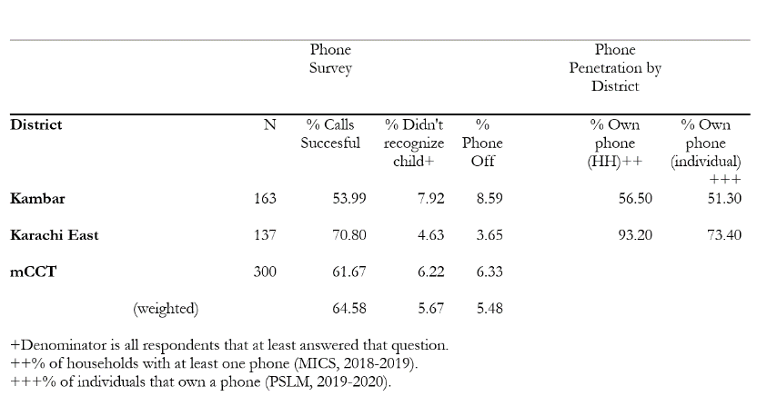
Table 18: Matching individual vaccines using matched household survey data with SEIR data using QR codes (using additional sample)

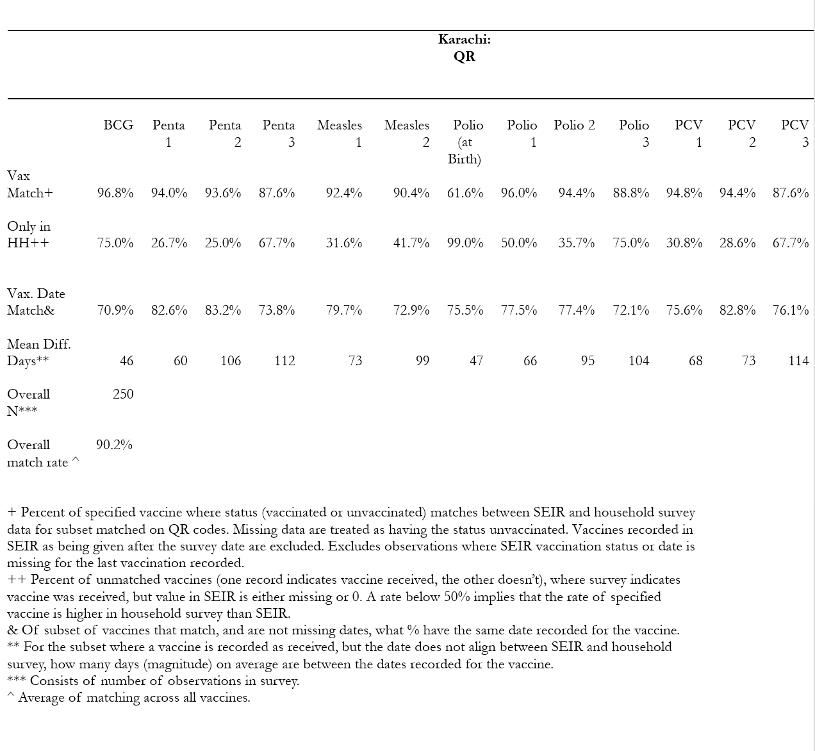
Table 18. Summary Statistics: Incentives Frequency (phone survey results from hotspots)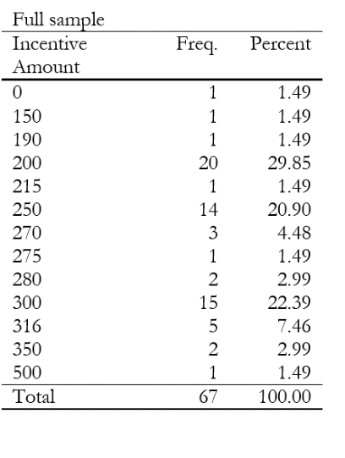
Note: all individuals were surveyed after the
change, and therefore should have received 275.

Table 19: Summary Statistics: Incentives Frequency (household survey results from additional segments)
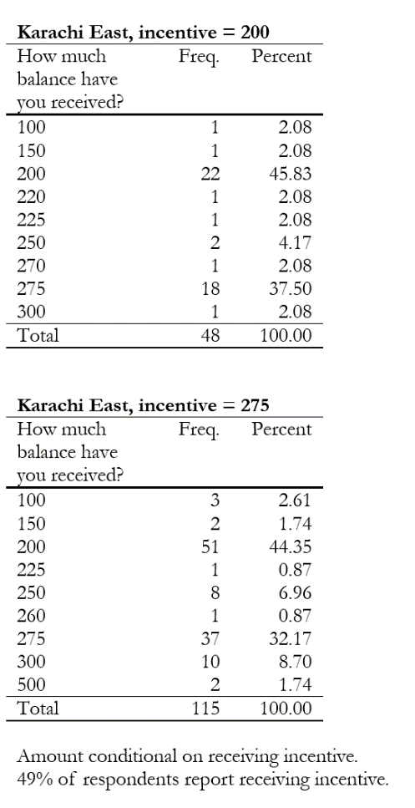

- Conclusion
In Part 2 of this report, we investigated a range of potential ways in which the SEIR data might systematically overestimate the impact of the mCCT program to assess the validity of our conclusions in Part 1. We also used data sources independent of SEIR to see if there was evidence of systematic fraud. We check the validity of the SEIR data, and check for evidence that might support potential fraud. We cannot prove there is no fraud. All we can do is check whether there are systematic irregularities that we would expect to find if there was a meaningful level of fraud.
We do this by phoning numbers in the SEIR database to see that these numbers are for real caregivers, that the caregivers received payments and that the payments were not systematically smaller than those that should have been sent. We also survey, in person, a representative sample of households in two mCCT districts. We use this to check that the correct phone number is linked to their child’s vaccination record and that they do not report getting systematically lower payments than they should, that the SEIR and the vaccination card has the same number of vaccines as is reported in the SEIR. We also use the household survey to understand the rate at which people switch phone numbers and the use of phones across households to understand if some of the rates of mismatch in the phone survey are reasonable. Finally, we use both the phone and household survey to assess the extent to which higher vaccination rates might induce higher usage of other health services.
We find inaccuracies in the SEIR data exist but do not see evidence of systematic bias that would undermine our results in part 1, nor do we see systematic discrepancies that would suggest fraud.
- We find no evidence that caregivers are systematically receiving smaller amounts than they should. While many caregivers do not report receiving 200PKR or 275PKR, they are as likely to report receiving more than these amounts as they are to report receiving less than these amounts. As many people report not receiving any transfer (which could be not noticing or fraud) we check whether there is systematic evidence of incorrect phone numbers being recorded for children.
- We find no evidence that phone numbers are systematically being given for fake children in order to collect fraudulent incentives. We are able to reach a high proportion of the phone numbers in the SEIR system, compared to other phone surveys we have conducted in Pakistan. The number of times the owner of the phone is unable to recognize the name of the child is similar in mCCT and nonmCCT districts when we call within 2 months of the last vaccination. The number of times a child is not recognized rises sharply with time suggesting that many cases of “child not recognized” will be due to changes in phone numbers over time. In the household survey we find turnover of phone numbers over time is reasonably high and a sharing of phone across 3 or more households happens in 11% of cases in Kambar but only 2% of cases in Karachi East areas.
- We find no evidence that incorrect phone numbers are being given for real children to misdirect incentives in a fraudulent way. Phone numbers on cards and phone numbers in SEIR match 91% of the time in Karachi East and 94% of the time in Kambar.
- We find no evidence that additional vaccines are being systematically and fraudulently added to real children’s records. When we match vaccine records from the household survey (vaccination cards) and vaccination records in SEIR they match 91% of the time in Karachi East and 80% of the time in Kambar. The mismatches go both ways: sometimes SEIR underestimate vaccinations (as reported on cards) and sometimes cards underestimate vaccinations (as reported in SEIR). The mismatch can occur when vaccinators forget to put the vaccine on the card or forget to put it in the SEIR. It can also occur when a child gets vaccinated in a campaign by someone who is a temporary vaccinator or when a child moves clinic, the card is lost, a new card and QR code is issued and vaccinators cant add the vaccine into the system as the child is too old (note when old vaccines are added to the system they are added as “retro” vaccines ie are not double counted and this does not impact our estimated effect sizes.
Finally, we find evidence that caregivers do use other services when they take their child to the clinic for vaccinations—mainly they collect drugs from the dispensary although they also get some consultations. We cannot say whether they would have collected these drugs from pharmacists if they had not come to the clinic for the vaccines nor can we say what drugs they collected

Annex

Table A1: Names and roll-in order in 7 of the mCCT districts
District (order of randomisation) | District roll-in dates | Town (order of randomisation) | Town roll-in dates planned | Actual roll-in dates
Karachi East | 26th January 2022 | Jamshed Town | 1/25/2022 | 1/25/2022
 |  | Gulshan Town | 2/10/2022 | 2/10/2022
 |  | East - Gadap | 2/23/2022 | 2/23/2022
Karachi Central | 1st March 2022 | Nazimabad | 3/1/2022 | 3/1/2022
 |  | New Karachi | 3/8/2022 | 3/9/2022
 |  | Liaquatabad | 3/14/2022 | 3/16/2022
 |  | North Nazimabad | 3/21/2022 | 3/22/2022
 |  | Gulberg | 3/28/2022 | 3/29/2022
Kambar | 1st April 2022 | Warah | 4/4/2022 | 4/5/2022
 |  | Shahdadkot | 4/7/2022 | 4/9/2022
 |  | Miro Khan | 4/12/2022 | 4/12/2022
 |  | Nasirabad | 4/18/2022 | 4/18/2022
 |  | Qubo Saed Khan | 4/20/2022 | 4/20/2022
 |  | Sujawal | 4/25/2022 | 4/25/2022
 |  | Kambar | 4/27/2022 | 4/27/2022
Hyderabad | 1st May 2022 | Hyderabad Rural | 5/4/2022 | 5/7/2022
 |  | Qasimaabad | 5/11/2022 | 5/11/2022
 |  | Latifabad | 5/18/2022 | 5/18/2022
 |  | Hyderabad City | 5/25/2022 | 5/25/2022
Jacobabad | 1st June 2022 | Thul | 6/7/2022 | 6/7/2022
 |  | Garhi Khairo | 6/16/2022 | 6/16/2022
 |  | Jacobabad | 6/28/2022 | 6/28/2022
Sujawal | 1st July 2022 | Mirpur Bathoro | 7/6/2022 | 7/6/2022
 |  | Sujawal | 7/13/2022 | 7/13/2022
 |  | Shahbander | 7/20/2022 | 7/20/2022
 |  | Jati | 7/27/2022 | 7/27/2022
Karachi West | 1st August 2022 | S.I.T.E. | 8/2/2022 | 8/2/2022
 |  | West - Gadap | 8/11/2022 | 8/11/2022
 |  | Orangi | 8/24/2022 | 8/24/2022

Note: The first district Karachi East was not randomized and the randomized followed from the second district.
Table A2: Phone number shared across couples
Karachi East
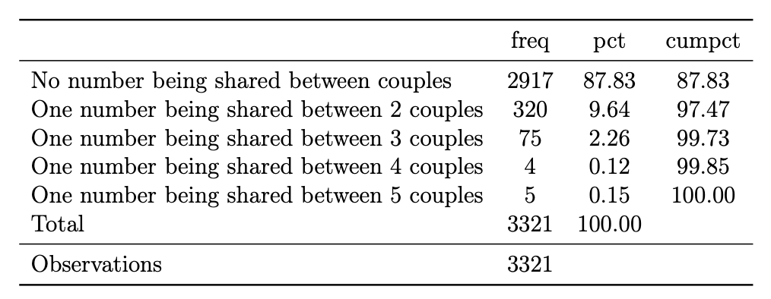
Kambar
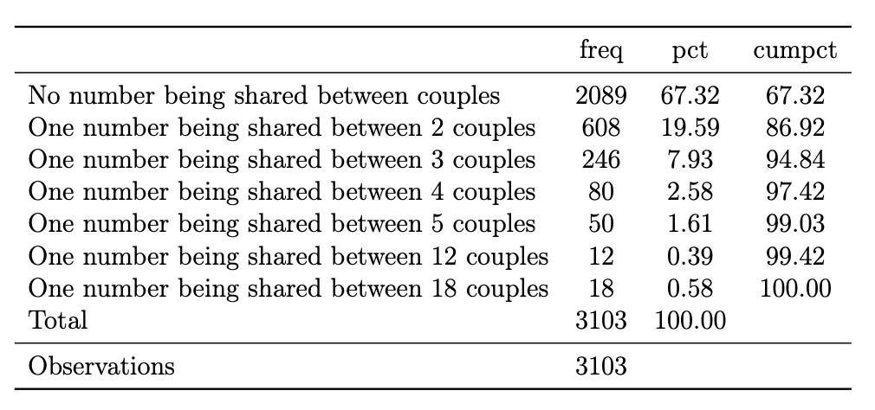
Note: No number being shared between couples means that the couple has a unique number. One number being shared between 2 couples means that there is at least one common number between two couples. The upper panel is for Karachi East and the lower panel is for Kambar.

Table A3: Health Services Available During Last Vaccine Visit (household survey results)
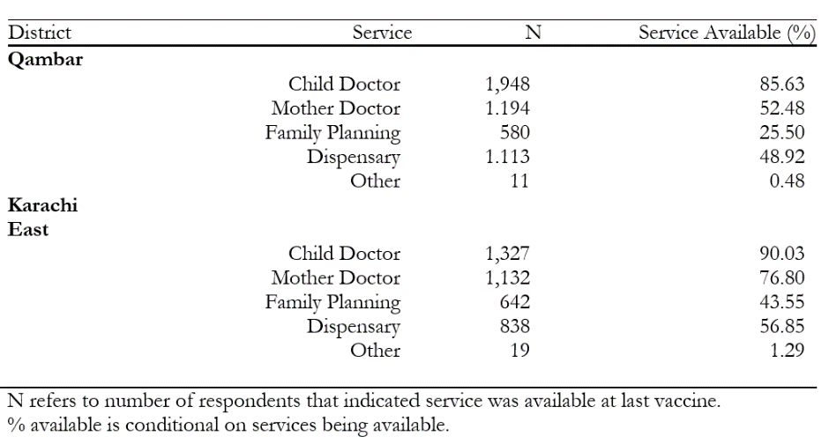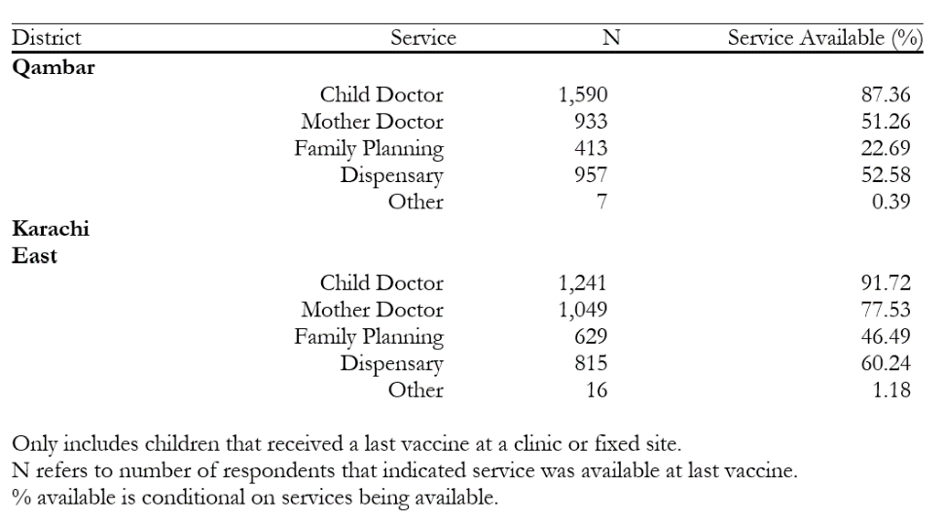

Table A4: Alternative Specifications for Lagged Impact
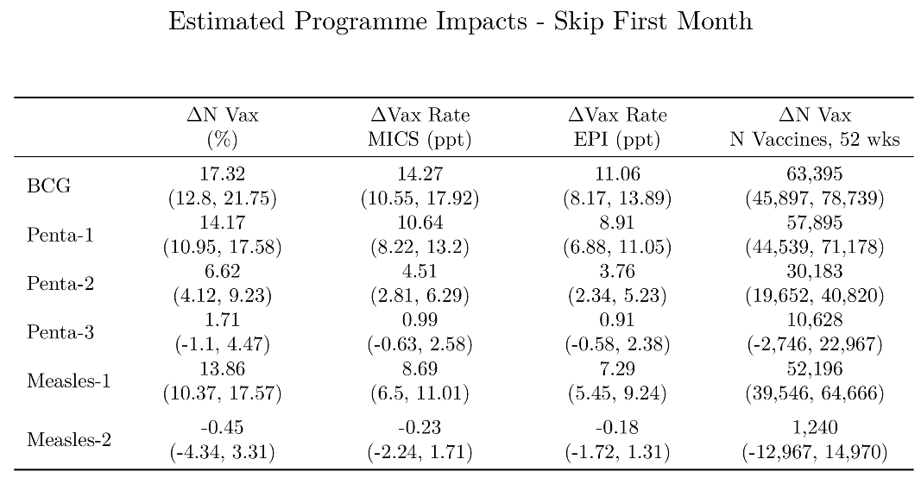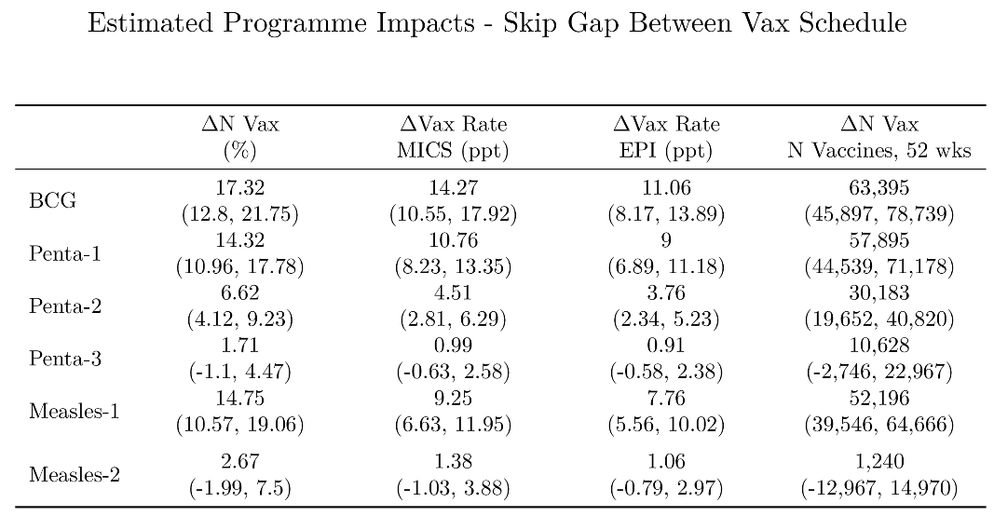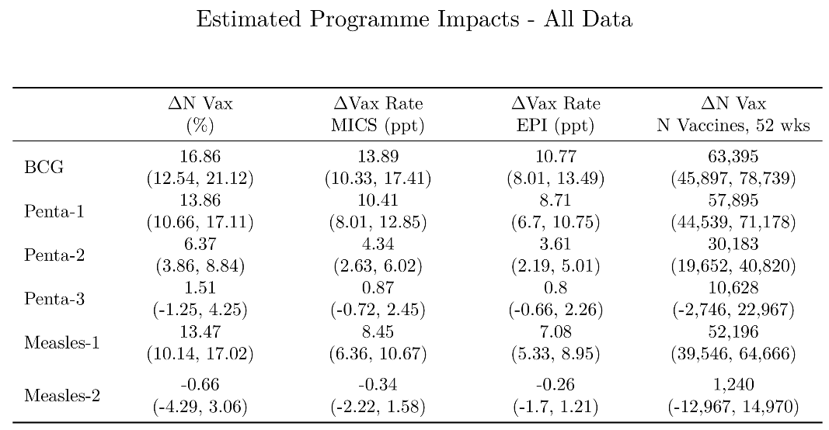
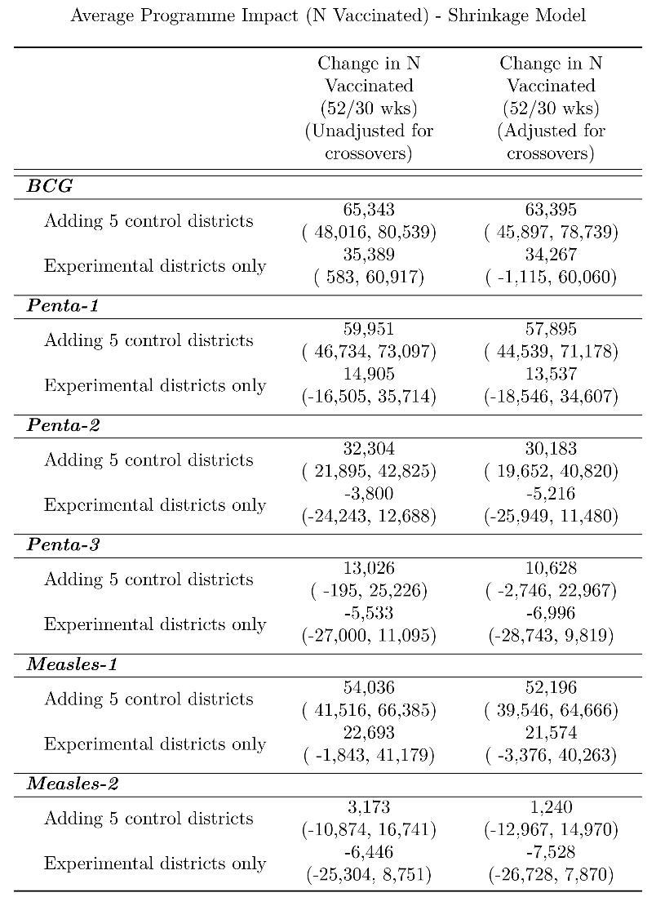

Main specification for other vaccines
Note that it is not clear how and when caregivers will find out about the program for BCG as it is the first vaccine in the schedule.
Figure A1: Estimates for the log of BCG vaccines in treatment vs control, balanced panel
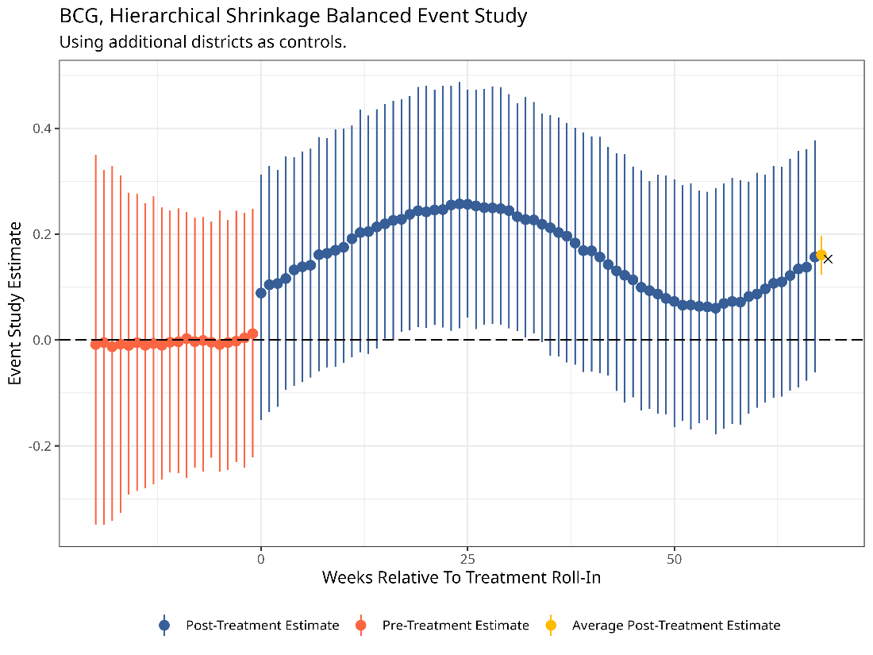

Figure A2: Estimates for the log of Pentavalent-1 vaccines in treatment vs control, balanced panel
Figure A3: Estimates for the log of Pentavalent-2 vaccines in treatment vs control, balanced panel
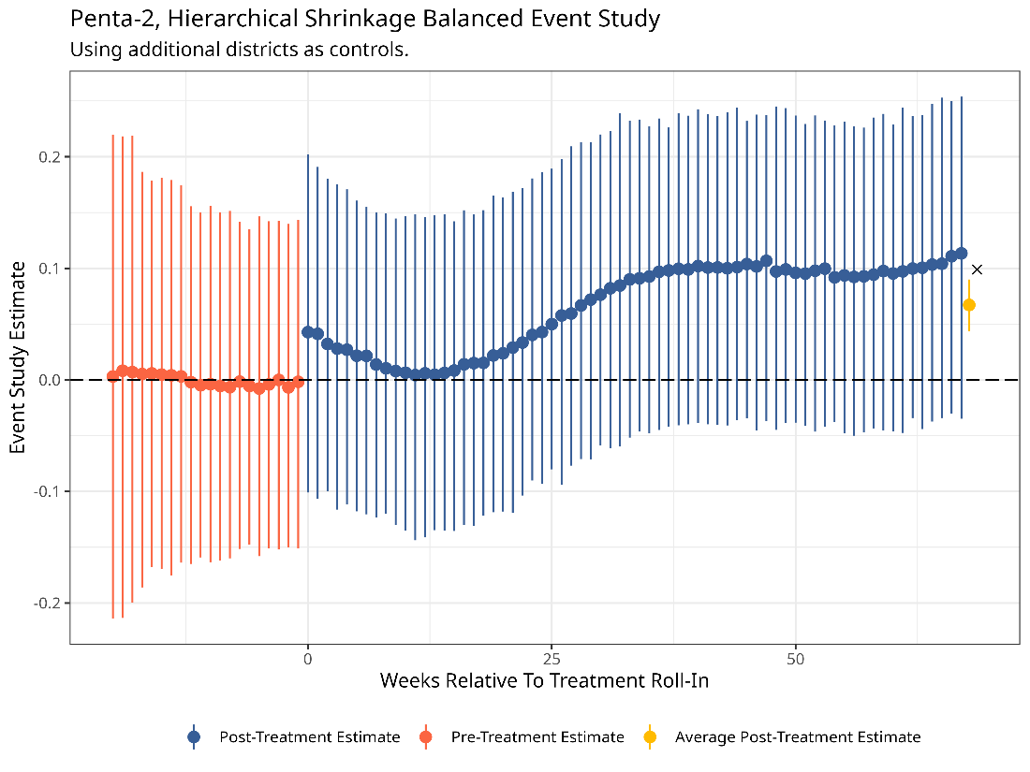
Figure A4: Estimates for the log of Pentavalent-3 vaccines in treatment vs control, balanced panel
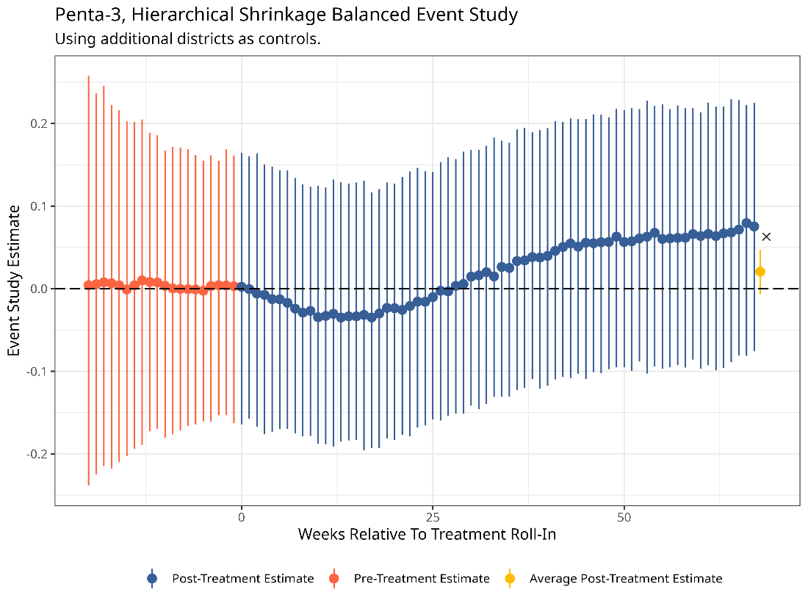
Figure A5: Estimates for the log of Measles-1 vaccines in treatment vs control, balanced panel

Figure A6: Estimates for the log of Measles-2 vaccines in treatment vs control, balanced panel
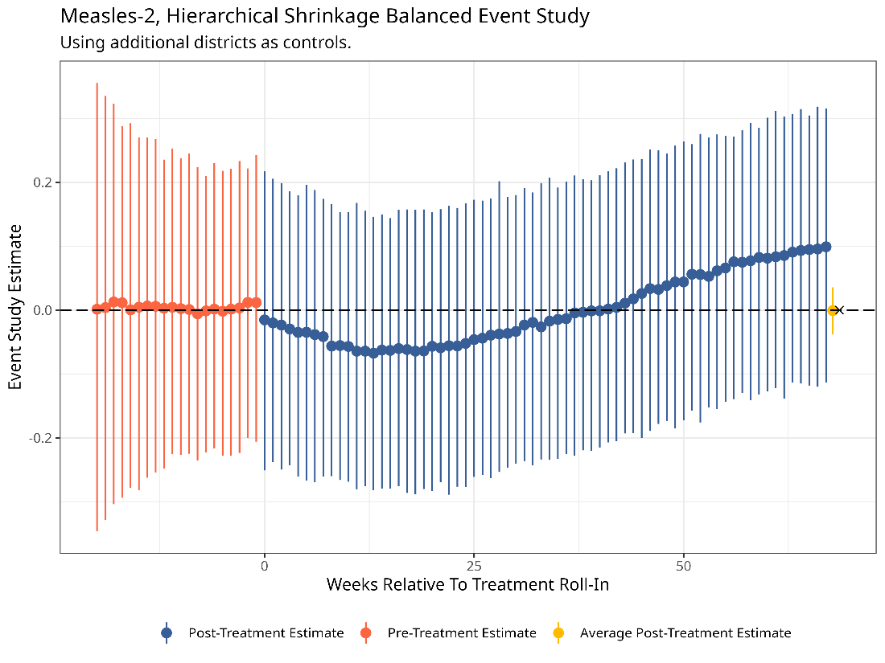

Process to calculate high-risk/low coverage districts for provincial scale-up of mobile phone-based conditional cash transfers (mCCTs) for immunization in low-coverage districts of Sindh, Pakistan

- The ZM data dump generated on Sep 01, 2021, was used to calculate crude coverages for the children of birth cohort 2020 by enrollment districts and UCs (v3 coverages by EPI targets-20210909 (1).xlsx).
- Crude coverages for all the antigens were calculated by dividing the number of children vaccinated for a particular antigen by the estimated annual live birth for BCG and annual surviving infants for remaining 18 vaccines for the year 2020 as provided by Government of Sindh, Pakistan (24th Feb 2020 RI Monthly Targets 2020 By Health Facility_AM.xlsx)
- The high-risk districts were categorized based on 20th percentile of crude penta-3 and crude measles-1 vaccines district coverage rates.
- There were 6 districts (20.0%) below the 20th percentile for penta-3 vaccine (coverage of 50.3%) which include Hyderabad, Karachi East, Karachi West, Karachi Central, Jacobabad, and Sujawal.
- Additionally, there were 6 districts (20.0%) below the 20th percentile for measles-1 vaccine (coverage of 30.7%) including Karachi Central, Karachi East, Karachi West, Karachi Malir, Sujawal, and Jacobabad.

Phone Survey
Figure A7: Stratification for the phone survey
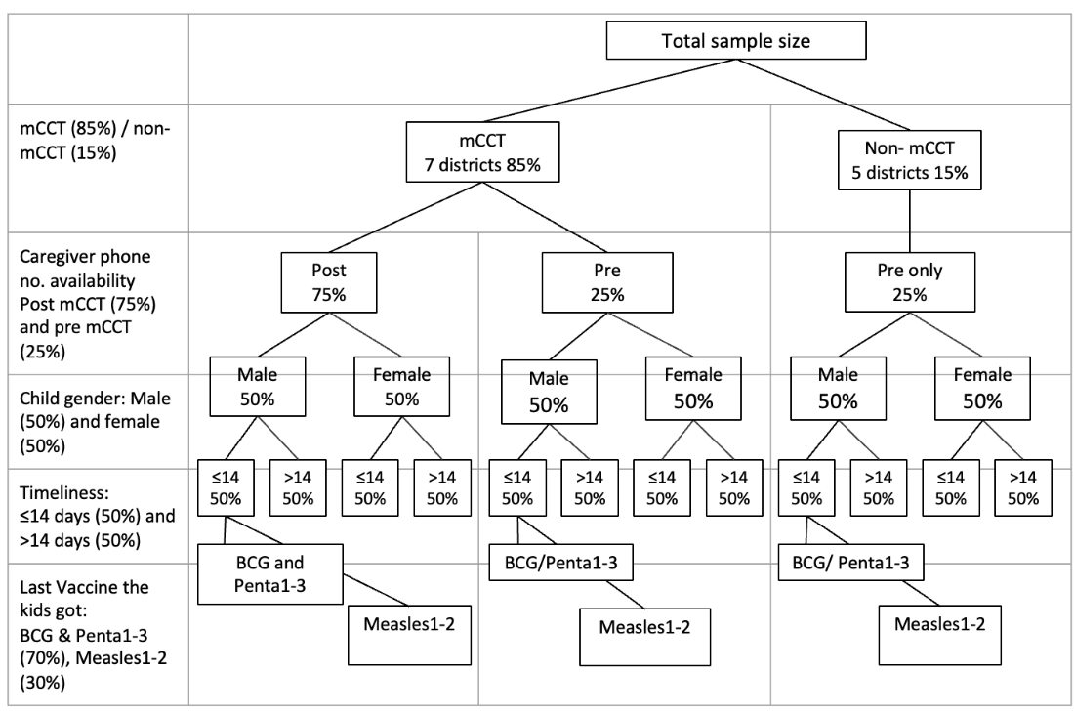
Household Survey

Table A8: Demographics of mCCT districts
District | Percentage Urban Population | Percentage Rural Population | Percentage of Female Population | Children Aged 0-4 years | Percentage Native Sindhi Speaking Population | Proportion of Households with at least One Mobile Phone | 12-23 Months Old Fully Immunized (card record and recall)
Jacobabad | 30% | 70% | 49% | 17% | 89% | 38% | 89%
Kambar | 30% | 70% | 49% | 16% | 95% | 51% | 60%
Sujawal | 11% | 89% | 48% | 16% | 98% | 34% | 51%
Hyderabad | 83% | 17% | 48% | 12% | 43.44% | 49% | 86%
Karachi Central | 100% | 0% | 48% | 10% | 3% | 68% | 67%
Karachi East | 100% | 0% | 48% | 11% | 12% | 73% | 54%
Karachi West | 93% | 7% | 47% | 13% | 6.88% | 61% | 67%
Source: the information has been taken from the Population Census 2017 and PSLM 2019-2020

A table describing the total number of vaccines due to the programme per year with and without adjustment for crossovers can be found in the annex.
We originally specified the number of vaccines rather than log of the number of vaccines given in a town but give the large variation in the size of towns we consider the log of the number of vaccines as more appropriate specification.
Imposing a balanced panel means we only include towns that we observe for the entire estimation window. We choose the longest possible estimation window that doesn’t discard towns due to balancing. Therefore, our final results use a window of 67 weeks, which is the length of time between the last town in Karachi West rolling in and the December 2023 data dump.
The Bayesian approach is identical to a nonparametric estimation.
Our strongest assumption is over how this relationship changes as the distance between weeks increases. We use the most popular modelling choice for Gaussian Processes, the squared exponential kernel, which has weights that decay exponentially in the square of the number of weeks between two treatment effects. There are two hyperparameters which we estimate for this kernel, the length and scale parameter, which controls how related far observations are and how wiggily the interpolation function is.
In the annex we show results using: the full sample (not accounting for impact lags), a gap of X weeks where X corresponds to the number of weeks between each vaccine according to EPI’s recommended schedule, an arbitrary cut-off of one month.
Measles 2 has a negative but insignificant coefficient on the percentage change in vaccines while the number of additional vaccines is positive. This is not a mistake. The % change in vaccination is an average across towns. When we calculate the increase in the number of vaccinations we apply the % change in each town to the number of vaccinations per town per week. As different towns are different sizes, and different weeks have fluctuations in the total number of vaccines, the latter will give a different result than the former.
Estimates for the change in raw numbers of vaccines (the last column) are for 52 weeks for the additional districts sample and 30 weeks for the experimental only sample since we don’t observe a control group post-30 weeks in the experimental sample.
Estimates are also noisier for M1-2 because we compare within expected due date, based off the child’s age, and by M1-2 any delay in earlier vaccines will cumulatively add up, leading to differences in realized vs expected due date. Conditioning on realized due-date post treatment could potentially introduce bias since the incentive could make treatment children more timely and lead to compositional shifts when we compare across treat and control.
To some degree the smaller effects for Penta-2 and Penta-3 are somewhat mechanical, given a late child induced into the program can only receive Penta-1 or Measles-1 (or BCG) at first before they’re eligible for Penta-2/3, although we’d similarly expect Measles-2 to have a sharp drop from Measles-2 under such a hypothesis.
Switching within control towns also increased over this period by 0.264 percentage points above the random switching rate which suggests other factors may have contributed to an increase in switching levels generally.
The census of 2017 could not be used as it was considered controversial and provides potentially unreliable estimates of the population.
For example, a team at the University of Chicago (Christina Brown and Maryiam Haroon) did a phone survey of casual day labourers after observing them on a full-day construction site for three consecutive days and found a pickup rate of 64.5% in Pakistan.
When a caregiver comes into a new clinic and says the child was vaccinated elsewhere for previous vaccines, these are recorded as ”retro” vaccines and are not included in our estimate in part 1.

