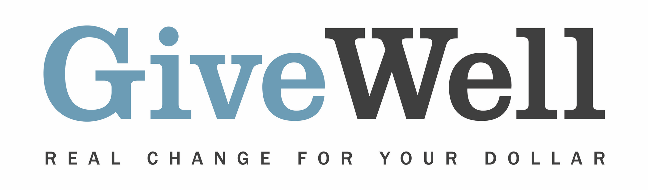
Dear (RECIPIENT'S NAME),
(YOUR NAME) has made a donation of $(DONATION AMOUNT) in your name to GiveWell. This donation will support GiveWell’s operations.
GiveWell is a nonprofit dedicated to finding outstanding giving opportunities. Unlike charity evaluators that focus solely on financials, assessing administrative or fundraising costs, we conduct in-depth research aiming to determine how much good a program accomplishes (in terms of lives saved or improved) per dollar spent.

Rather than try to rate as many organizations as possible, we focus on the few that stand out most in order to find and confidently recommend the best giving opportunities, according to our criteria, to donors. We have directed more than $2 billion in donations to organizations and grants we've recommended.
GiveWell currently recommends four top charities: Malaria Consortium (seasonal malaria chemoprevention program only), Against Malaria Foundation, Helen Keller International (vitamin A supplementation program only), and New Incentives. These charities help prevent infectious disease and avert child mortality.
If you're interested in staying up to date on GiveWell's progress, you can sign up for updates here: www.givewell.org/updates.

Thank you for your support!

Sincerely,
GiveWell Staff
www.GiveWell.org

