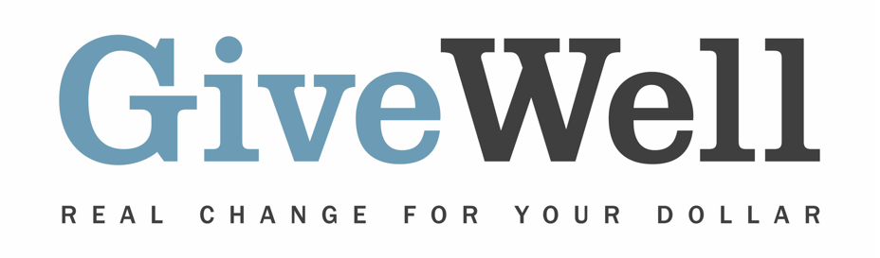
Dear (RECIPIENT'S NAME) ,
(YOUR NAME) has made a donation of $(DONATION AMOUNT) in your name to GiveWell. This donation is designated for the support of GiveWell’s All Grants Fund.

This donation will support the full range of GiveWell’s grantmaking. Our goal is to fund the highest-impact giving opportunities we identify, some of which may be represented by programs that are outside of our top charity list. GiveWell recommends funding for a variety of opportunities:

- Potentially cost-effective and scalable programs that may lead us to make larger grants in the future, if successful
- High-impact, cost-effective opportunities that we don’t plan to scale
- Organizations aiming to influence public health policy
- Organizations producing research to aid our grantmaking process
- Organizations that raise funds for our recommended charities
- GiveWell’s top charities

GiveWell is a nonprofit dedicated to finding outstanding giving opportunities. Thousands of hours have gone into finding and analyzing GiveWell's recommendations. They are evidence-backed, thoroughly vetted, and underfunded. For more information on GiveWell’s work, please visit us online at www.GiveWell.org.

Thank you for your support!

Sincerely,
GiveWell Staff
www.GiveWell.org

