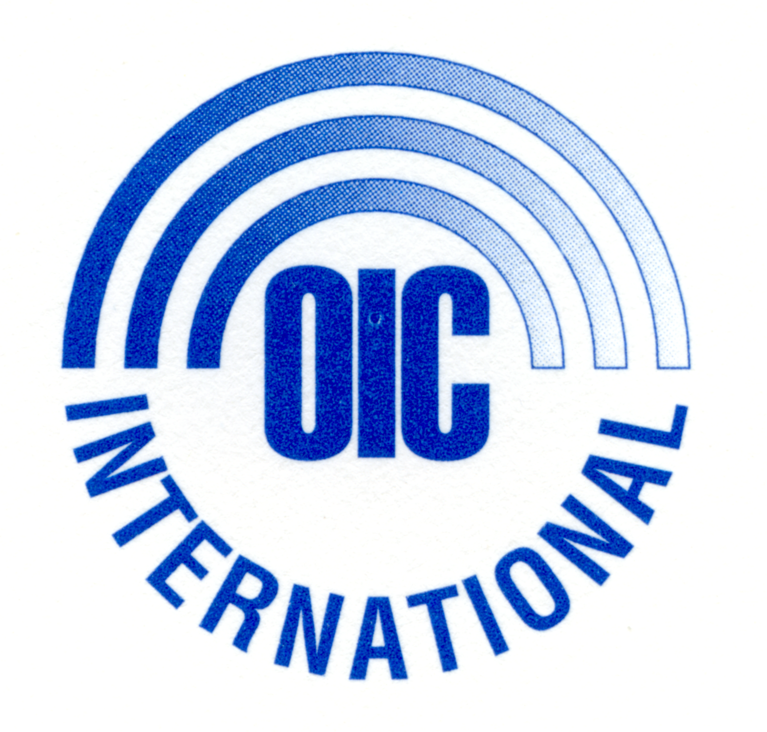

Opportunities Industrialization Centers International, Inc.

37 Years of Sustainable Development Services

ANNUAL REPORT

FY 2006

Edmund D. Cooke Jr. Ernest L. Jolly
Chairman of the Board President & CEO

This report has been prepared for the PVO Registration of OIC International with the United States Agency for International Development.

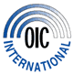
OIC INTERNATIONAL, INC.
Annual Report
FY 2006
October 1, 2005 – September 30, 2006

TABLE OF CONTENTS

INTRODUCTION iv
PART I: | ORGANIZATIONAL BACKGROUND
A | OICI Mission and Strategy | 01
B | Key Elements of OICI Methodology | 03
C | Global Network of OICI Affiliates | 04

PART II: | U.S. GOVERNMENT FUNDED PROGRAMS
A | Enhancement of Household Agriculture, Nutrition, Risk Reduction & Community Empowerment Program (ENHANCE), PL-480 Title II, Ghana | 09
B | Food and Livelihood Security in Pita and Telimele, PL-480 Title II, Ghana, Guinea | 27
C | FarmServe Africa – John Ogonowski Farmer-to-Farmer Program: Ghana, Guinea, Mali & Nigeria | 39
D | Institutional Capacity Building (ICB)Program, Food Security Sector, HQ, Côte d’Ivoire, Ghana, Guinea, Togo | 55
E | Jobs and Business Development Initiatives (JOBS), Nigeria | 61
F | Innovative Community-Based Academic & Computer Learning & Mitigating Conflict through Employment Generation and Civics Education, Ethiopia | 73
G | Building Global Bridges, International Development Career Training, HQ & selected Universities in Philadelphia | 83
H | Farming and Business Skills Development Project, Côte d’Ivoire | 89
I | Farm Income Improvement Project, Togo | 107

PART III: | PRIVATE SECTOR FUNDED PROGRAMS
A | Reproductive Health Education and Skills Training for Youth, Ethiopia | 133
B | Mining for Sustainable Development: Sustainable Community Empowerment & Economic Development (SEED), Ghana | 141
C | Mining for Sustainable Development: Livelihood Enhancement and Community Empowerment Program (LEEP) Ghana | 148
D | Economic Empowerment through Micro-Credit, Côte d’Ivoire | 151

PART IV: | SUCCESS STORIES
A | GUINEA  - Health & nutrition  - Soil fertility  - Diet improvement  - Improvement in governance & status of women  - Food distribution | 157
B | GHANA  - Community Empowerment (SEED Project)  - Livelihood Enhancement (LEEP Project) | 161

PART V: | ANNEXES
I | OIC International Directory | 167
II | OIC International Board of Directors | 173
III | OIC International Headquarters Staff  OIC International Country Representatives | 175  176
IV | OIC International Capability Statement | 177

OIC INTERNATIONAL, INC.
Annual Report
FY 2006

Introduction

This report is for the registration of OIC International (OICI) as a U.S. Private Voluntary Organization (PVO) with the U.S. Agency for International Development (USAID). It integrates the individual annual program reports that OICI already submitted for each of its funded programs to the respective funding agencies. It is a factual report with a high level of detail and is the most extended and integrated annual report version of OICI.

This report covers OICI’s operations in seven (7) program countries and its headquarters as it implemented thirteen (13) government and private grants/contracts in FY 2006. The seven (7) program countries include Ethiopia, Côte d’Ivoire, Ghana, Guinea, Mali, Nigeria and Togo. Other than its operations in these countries, OICI also maintained affiliate relationships with OIC institutions in eleven (11) other countries that comprise nine (9) in Africa in addition to Poland and the Philippines. This report does not cover these eleven (11) countries.

Funding support to OICI in FY 2006 came from the U.S. Government – USAID, USDA, USDOL – and private sources including the Lucile Packard Foundation, Citigroup Foundation, Newmont Ghana Gold Limited and Gold Fields Ghana. OICI and its affiliates also benefited from individual contributions in the U.S. and host countries, U.S. corporate contributions and host governments’ support.

OICI’s programs in FY 2006 reflect a wide range of development assistance in several areas as summarized below:

Agriculture and Natural Resource Management  - Crop & vegetable production  - Improving access to agricultural input  - Post harvest handling and storage  - Livestock production and management  - Water and sanitation  - Micro-irrigation  - Sustained natural resource management  - Non-traditional agricultural products with great potential markets | Health & Nutrition  - Adolescent health education  - HIV/AIDS and infectious diseases prevention  - Care for people living with HIV/AIDS  - Support to orphan and vulnerable children  - Maternal child health and nutrition  - Community health and hygiene
Employment creation  - Vocational technical training for employment and income generation  - Career guidance and counseling  - Creating access to employment generation services  - Strengthening the operational capacity of job creation and placement services  - Livelihood skills development | Business development services  - Creating access to microenterprise development services  - Business management training and consulting  - Microcredit and support services  - Income generation training for women
Civil society development  - Community development & empowerment  - Strengthening women participation in community affairs  - Post conflict resettlement assistance  - Development of corporate accountability and meting social obligations | International development career preparation (U.S. audience)  - Education on the development world and related jobs opportunities  - Counseling and guidance on international development as a career choice  - Assistance in job search and application

Due to the highly diversified scope of operations as reflected in this report, it is difficult to present an executive summary in the traditional sense without running the risk of omitting some of the significant aspects of the year’s program performance. It is recommended – therefore – that the readers review first the table of contents for an idea on the diversity of OICI’s programs in FY 2006. A detailed review of the report may follow later and with particular focus on the areas of specific interest to the reviewers.

The following country representatives and program managers of OICI have made this report possible through the program information that they provided:
- Dr. Makonnen Fantaw, Country Representative and Manager of the USAID GDA-funded program and the Packard-funded program, Ethiopia.
- Carla Denizard, Country Representative and Manager of the USAID-funded ENHANCE program and the SEED and LEEP programs financed by mining companies, Ghana.
- Leon Sakho, Country Representative and Manager of the USAID-funded FLSPT program, Guinea.
- Jacqueline Hardware, Country Representative and Manager of the USAID-funded JOBS program and local sustainability initiatives, Nigeria
- Emmanuel Atieku, Director of Food Security Programs, Manager of the USAID Institutional Capacity Building (ICB) grant.
- Michelle Frain-Muldoon, Director and Manager of the USAID Farmer-to-Farmer/FarmServe grant.
- Rachelle Martinez, Manager of the USDOL-funded Building Global Bridges project.
- N’Doua Affély, Executive Director, Côte d’Ivoire OIC (provider of all program information from Côte d’Ivoire).

Other valuable contributors – particularly in research, program reports review and facilitating access to additional program data - include Dr Alfred Tambe, Christina Kocisko and Christine Simpson at OICI headquarters, and Dr John Azu and Ferdinand Nyantakyi-Dapaah of OICI- Ghana.

For questions on this report, if any, please contact Quy D Nguyen, report preparer, email: quynguyen@oici.org

Innovative Community-Based Academic & Computer Learning & Mitigating Conflict through Employment Generation and Civics Education
Reproductive Health Education and Skills Training for Youth
Enhancement of Household Agriculture, Nutrition, Risk Reduction & Community Empowerment Program
Sustainable Community Empowerment & Economic Development
Livelihood Enhancement and Community Empowerment Program
Food and Livelihood Security in Pita and Telimele
Jobs and Business Development Initiatives

